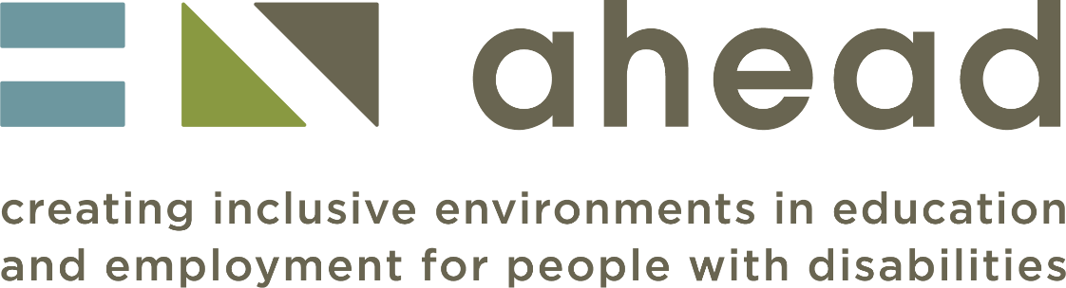

AHEAD Accessibility Statement for ARK Courses

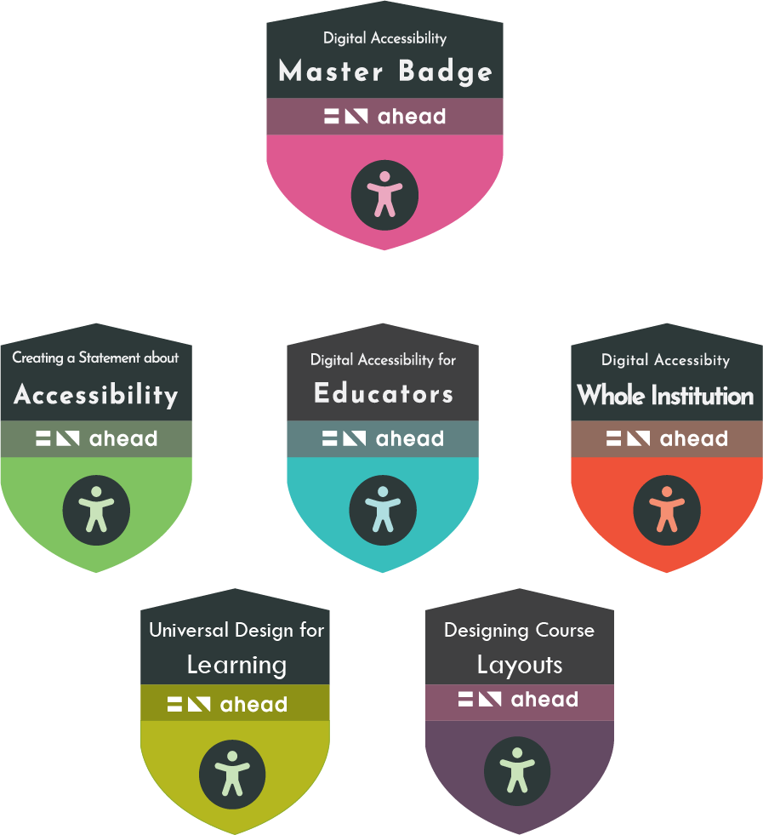
Contents
Introduction 3
What should work for all users (and how it helps) 3
Visual Appearance 3
Colours: 3
Magnification: 4
Navigation 4
Module level: 4
Page level: 4
Hyperlinks: 4
Skip links: 4
Landmarks 4
Media 4
Keyboard accessibility 5
Text-to-speech compatibility 5
Known Issues 5
Moodle course image 5
Visual Appearance 5
Colours: 5
Videos 6
Interactive graphics 7
Multichoice quizzes 7
Preparation of this statement 7
Feedback and contact information 7

Introduction

This is the accessibility Statement for AHEAD online accessibility short courses. It applies to the following courses:

- Digital accessibility - a whole institutional approach,
- Digital Accessibility for Educators,
- Developing an Accessibility Statement,
- Designing Course Layouts for Learner Success,
- Universal Design for Learning - Getting started.

This content has been developed to be as accessible as possible within the constraints of the tools available. Being accessible gives more options for more users and allows you to personalise your view of the content and to explore it on a range of platforms from mobile phones to laptops, tablets, or screen readers.

The courses have been created on Articulate Rise and are delivered via the AHEAD Moodle platform. There is a downloadable Word version available for each course too. This has the same content (but obviously not the interactivities).

If it is helpful to you, we provide links below to more information on the accessibility of Articulate Rise and the Accessibility of Moodle.

Articulate Rise voluntary product accessibility template (VPAT)

RISE progress on accessibility to date

Moodle platform accessibility guidance

What should work for all users (and how it helps)

Visual Appearance

Colours:

We have taken care to ensure the colour contrasts under our control meet accessibility guidelines for text and buttons.

We do not use colour alone to convey information. The only exception is a colour contrast quiz in one module where providing extra information would undermine the purpose of the quiz.

Using either browser settings or free browser plug-ins (such as HighContrast or
ScreenShader) it is possible to change the background colour/contrast.

Magnification:

The content is designed to be responsive. This means you can magnify in the browser up to 400% (using Control and +) without loss of functionality.

The default text size can be increased up to 200% without loss of functionality - the one exception we are aware of is a Flip card activity where the ﬁrst line on the card may be truncated.

Navigation

Module level:

You can navigate through the content using the side panel table of contents. This helps you quickly revisit content or skip ahead. Note that some sections require knowledge to build sequentially and so the ability to skip ahead may be deliberately restricted.

Each page has a link at the top leading back to the previous section. A Continue button at the bottom of the page takes you to the next section in the sequence.

Page level:

You can navigate through the content using the side panel table of contents. This helps you quickly revisit content or skip ahead. Note that some sections require knowledge to build sequentially and so the ability to skip ahead may be deliberately restricted.

Each page has a link at the top leading back to the previous section. A Continue button at the bottom of the page takes you to the next section in the sequence.

Hyperlinks:

Hyperlink text is unique and meaningful to aid navigation by screen reader users.

Skip links:

A Skip to Lesson link at the top of each page makes moving round the page much more effective for keyboard only users.

Landmarks

The course content is structured with ARIA landmarks so screen reader users can rapidly navigate between navigation items (Navigation menu, Course outline, Lesson content and Lesson header).

Media

Where relevant, we have used video clips to give a real-world context to the information. All videos have accurate captions and, where appropriate, visual content on the screen is described. Transcripts are also provided for each video.

The embedded video player is keyboard accessible and can be operated without a mouse.

Decorative images have been marked as such. Other images have been given an appropriate description.

Keyboard accessibility

You can navigate the entire site and operate all its features using either a mouse or a keyboard. The relevant keys are the Tab key, Shift+Tab (to go back), the Spacebar, Enter key and the arrow keys.

The current keyboard focus is clearly visible as you tab around the content.

There is a skip to section link near the top of the page, so you do not need to tab through the menu each time you move to a new page.

There are no keyboard traps in the activity types we have chosen.

Text-to-speech compatibility

All the text-based content can be accessed via text to speech tools. This includes
- commercial tools,
- built in browser tools (such as Read aloud in Microsoft Edge),
- free text-to-speech plug-ins such as Selection Reader or Read aloud.

Known Issues

Moodle course image

It is not possible to add an alt tag to the image tile representing the course on Moodle. This is in the Moodle development pipeline.

Visual Appearance

Colours:
There are parts of the Articulate Rise interface where contrasts fail guidelines – for example, the Submit button for quizzes and the contrasts on the cookie statement. We are unable to change these default settings.

The Knowledge Check colour contrast ﬂip card activity in M3 relies on visual estimation of contrast so will not be meaningful for some visually impaired users.

The default line height cannot be adjusted using plugins such as Line Height Adjuster.

Videos

There is a small issue for screen reader users. Although the embedded videos are keyboard accessible, the Play button does not announce to a screen reader that it has become a Pause button once the content starts playing. To pause the video, listen for the Play button again!

Interactive graphics

Interactive graphics have been created to be accessible but the accessible name for each clickable hotspot is "marker" which is not intuitive. We have not found a way to change this.

Multichoice quizzes

Some screen readers (JAWS and Windows Narrator) read the question then announce the unchecked radio button then read the question again. This was not an issue with NVDA. We have not been able to modify the code to change this behaviour.

Preparation of this statement

This statement was prepared in February 2022 and updated in December 2022.

Testing was conducted during development as a result of a bespoke training course to upskill the development team. A range of assistive technologies including Windows Narrator, NVDA and browser plug-ins were used.

In addition to iterative testing during development, the development and support team tested each module’s accessibility in the review stage before signing off. This sometimes resulted in changes to the interactions used.

An expert screen reader user provided ﬁnal guidance and support on the areas where the development/support team were less conﬁdent of their screen reader skills.

In December 2022, the two new short courses – “Designing course layouts for learner success” and “Universal Design for Learning - getting started” - were tested with JAWS by a blind screen reader user. Her observations resulted in some redesign of interactivities and updates to this statement.

Feedback and contact information

While we have taken every care to maximise the accessibility of this resource and minimise any barriers, we cannot anticipate every potential use case. If you experience any barriers when using this material, we would be grateful to hear from you. Please be as speciﬁc as possible, explaining what the barrier was, what you were trying to do and where it occurred in the resource.

Please also note that accessible Word versions of these short courses are available on request. They lack the interactive elements but contains all the same content and learning opportunities.

Please contact: AHEADcourses@ahead.ie

