Building the Future 2026
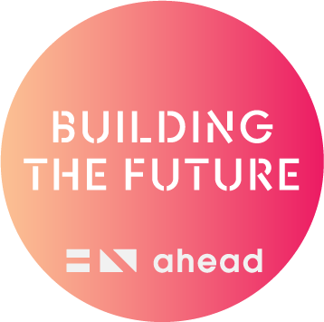
  - Participant Guide and Info Pack
  - 27th May 2026
  - Citi, 1 North Wall Quay, D01 T8Y1

Contents
About the Event 3
What is Building the Future? 3
What does the event look like? 3
Where is the event taking place? 3
How can I get there? 3
What time do I need to arrive? 3
What should I wear? 4
What should I bring? 4
Will there be food or lunch? 4
What is Bingo Networking? 4
Who do I speak to if I need guidance at the event? 4
Agenda 5
Accessibility Information 7
Further Information 8
Event Map 9
Visual Guide 10

About the Event

What is Building the Future?
The event is designed for and attended by students and graduates with disabilities. Participants will have the opportunity to speak with employers, take part in workshops and get their headshot taken. They will also have the chance to book in for a mock interview or to get their CV reviewed. This guide is designed to give you a better understanding of what the event is, and what will happen on the day.

What does the event look like?
If you’ve never been to Building the Future before, think of it like a graduate fair, maybe you’ve been to one in your college or university, or like a smaller version of the gradireland fairs in the RDS. There will be 18-19 companies hosting stands on the day with their HR staff, so it’s a great way to network and meet with the employers face to face and ask them questions about their opportunities or what it’s like to work in their company.

Where is the event taking place?
Building the Future will take place at Citi, 1 North Wall Quay, Dublin, D01 T8Y1. The building faces the River Liffey and is located in the IFSC Docklands area.

How can I get there?
Public Transport: The Luas (Red Line) stops are; George’s Dock and NCI ISFC Mayor Square, both of which are a 300-metre walk from Citi. It is also served by Busáras and Connolly train stations.
Car Parking: There will be no car parking facilities available at Citi, however there are two multistorey car parks nearby. IFSC Carpark (opposite Citi) has a rate of €4.90 per hour, alternatively you can park at the National College of Ireland for an all-day rate of €10 or €3 per hour.

What time do I need to arrive?
Registration opens at 9:15am, with the event welcome taking place at 9:45am. The first workshop will be at 10:00am before the employer exhibition space opens at 10:30. We would encourage you to arrive early if you would like to attend the workshops, as there is limited space available in the workshop room.
Last entry to the event is at 12:00pm.

What should I wear?
As this is a careers event, where you will be meeting with HR recruitment staff from some of biggest multinational companies in Ireland, dress to impress. This means you should look professional i.e. smart casual or as if you were going to work.
If you have a mock interview, then you should dress like you are going for interview. It also shows the employer that you are serious about looking for work and want to create the right impression.

What should I bring?
You are advised to bring several copies your CV along on the day as there are no printing facilities.

Will there be food or lunch?
In your goodie bag, you will receive a bottle of water, popcorn, a snack bar and a bag of jellies when you arrive at the event. You can also refill your water bottle using the water fountains available in the Citi canteen.
There will be sandwiches in the employer exhibition space served at 12:15pm.

What is Bingo Networking?
On arrival, we will give you a bingo card with different actions in each box. You use this to go up to employers and ask them about the items in the box. If you complete all boxes, return it to the AHEAD registration desk. Your bingo sheet will then be corrected and entered into a raffle where you could win €50!
Winner of the Bingo Networking will be announced at 1:30pm before the final workshop.

Who do I speak to if I need guidance at the event?
There will be lots of AHEAD Staff available on the day if you have any queries. There will also be a few Citi volunteers with signs that read ‘Got a Question?’ that you can approach with any queries or concerns.

Agenda
9:15am: Registration Opens
When you arrive at Citi, you will need to go to the registration desk to sign in. You’ll be given a name badge and a goodie bag which contains a map, an agenda and some of our promotional material with a bottle of water and some snacks. This bag is also useful for collecting and storing any materials you get from the employer stands, especially all the free pens!
There will be some couches to the right of the building entrance where you can sit if you arrive early.
9:45am – 10:00am: Welcome
The event will begin at 9:45am with a welcome from representatives from AHEAD and Citi. They will introduce the event and give an overview of the day.
10:00am – 10:30am: Workshop 1
Approaching CVs and Interviews with Confidence (Bord Bia)
The first workshop of the day will kick off at 10:00am with a workshop covering tips and tricks for developing your CV and some guidance on preparing for interviews. The session will be about 30 minutes long including some time at the end where you can ask questions. There is limited seating in the workshop room so please do arrive early if you would like to guarantee a spot as it will operate on a first come first served basis.
10:30am – 1:00pm: Exhibition Space Open
The employer exhibition space will open after the first workshop has finished. The main exhibition space will be a busy area where you can chat directly with employers at their stands about opportunities they have, about their diversity and inclusion initiatives and maybe even get some goodies!
10:45am – 1:30pm: Mock Interviews
In our mock interview sessions, employers have volunteered their time to give you direct feedback on your interview skills. Mock interviews require pre-booking at the time of purchasing your ticket. Your allocated mock interview time will be emailed to you in advance of the day.
On the day, you should arrive at the mock interview area 5 minutes before your allocated time and alert the volunteers you are there. You will then be brought into the waiting area for your mock interview. The mock interview be 20 minutes in duration and 5 minutes for feedback.
10:45am – 12:30pm: CV Clinics
You can make an appointment for a CV Clinic when signing in on the morning of the event. Appointments are first come, first served. There are limited number of CV clinic slots available during the day so try sign up as soon as you arrive at the CV registration table.
Please remember to bring a copy of your CV as there are no printing facilities available at the event. When you sign up, you will be allocated a time slot. Please arrive to your appointment 5 minutes prior to this time slot and alert the volunteers you are there. You will then be brought into the waiting area for your CV review, which will be 10 minutes long.
10:45am – 12:45pm: Get-A-Headshot Station
You can make an appointment for a headshot when signing in on the morning of the event. Appointments are first come, first served.
When you sign up, you will be allocated a time slot. Please arrive to your appointment 5 minutes prior to this time slot and alert the volunteers you are there. You will then be brought into the waiting area for your headshot where the photographer will spend about 5 minutes with you taking some photos. Your headshot will then be emailed to you a few days after the event.
1:00pfirst come: Workshop 2
Bridging into Tech: Supported Employment Pathways into Ireland’s Tech Sector (FIT)
The second workshop of the day will cover the landscape of the tech sector in Ireland, highlight the routes into the sector and you’ll learn about FIT’s apprenticeship programme. The session will be about 30 minutes long including some time at the end where you can ask questions. There is limited seating in the workshop room so please do arrive early if you would like to guarantee a spot as it will operate on a first come first served basis.
1:30pm – 2:00pm: Workshop 3
TEMET NOSCE (“Know Thyself”): Knowing yourself and your limits (Citi)
The third workshop of the day will be delivered by a Citi employee, where he will explore the impact of acquiring a physical disability in childhood and discuss his personal journey to adulthood. The session will be about 30 minutes long including some time at the end where you can ask questions. There is limited seating in the workshop room so please do arrive early if you would like to guarantee a spot as it will operate on a first come first served basis.
The event will end at 2:00pm.

Accessibility Information
Accessible Building
There is level access from the street to the building. The event is entirely on ground level with areas for seating throughout the exhibition space. Wheelchair accessible bathrooms are located near the exhibition area, however, you should find a Citi volunteer to direct you to these bathrooms.
Quiet Room
A quiet room is available for sensory respite with fidget toys and low noise from 10:45am - 1.00pm.
ISL Interpreters
We have booked two ISL Interpreters for the day - however, you must inform us when booking your ticket if you wish to avail of ISL interpreters so we can schedule the interpreters accordingly. If you have requested an interpreter, please let the AHEAD staff at the registration desk know when you arrive.
Sighted Guides
There will be sighted guides available for this event, please do let us know in advance if you need a sighted guide. If you have requested a sighted guide, please let the AHEAD staff at the registration desk know when you arrive.
Captions for workshops
The welcome and workshops will have autogenerated live-captions available on screen.
Personal Assistant or Companion
You are very welcome to bring your personal assistant or a companion with you to the event. We just ask that you please share their name with us in advance of the event for security purposes.
Slides
All slides will be accessibility checked and will be shared in advance of the event.
Employer Disability Awareness Training
All employers attending the event are offered a chance to attend disability awareness training in advance. Citi volunteers are also provided with specific volunteer training and speakers are briefed on guidance on giving inclusive presentations.

Further Information
If you have any questions or need any further information about the event, you can contact AHEAD’s GetAHEAD Officer Banba Fitzgerald, at banba.fitzgerald@ahead.ie.
You can also find more information on the Building the Future 2026 website.
If you have any questions on the day, you can ask the AHEAD staff and Citi volunteers, and they will be happy to help!
We look forward to seeing you at Building the Future!

Event Map
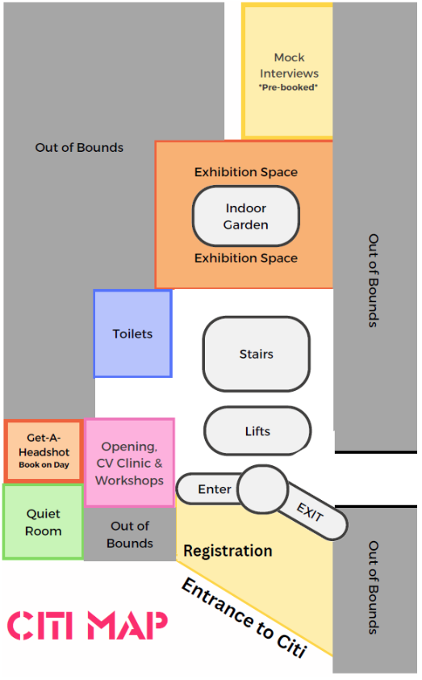

Visual Guide
The images in this section are intended as an additional visual aid to help attendees become familiar with the event space in advance. As some images contain maps, layouts and multiple visual details, many images do not contain alternative text descriptions. Relevant information about the venue and event layout is provided throughout this document where possible.
Sighted guide support will also be available on the day for attendees who may benefit from assistance navigating the space. If you have any questions or specific access requirements in advance of the event, please let us know.
Event Building
The event is located in the Citi Offices:
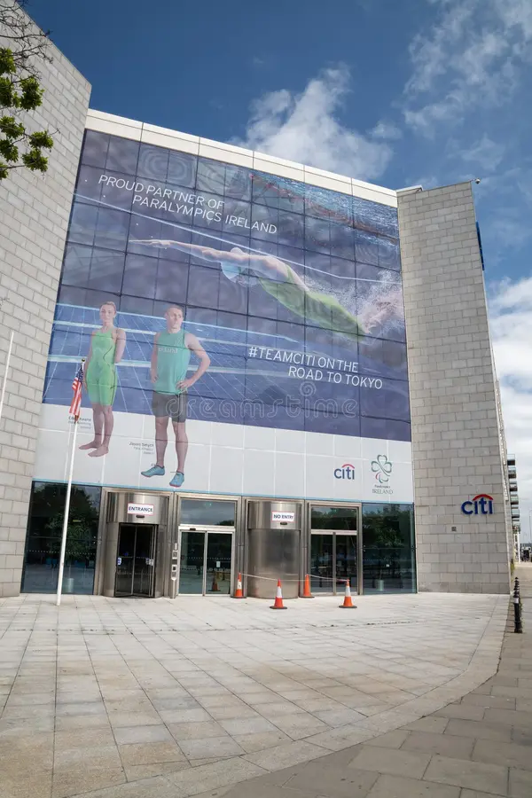
Registration Space
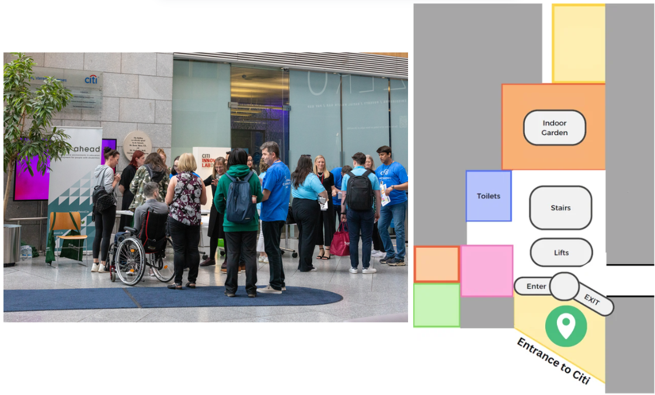
Please note that the green circle in each image marks the location of each element of the event.

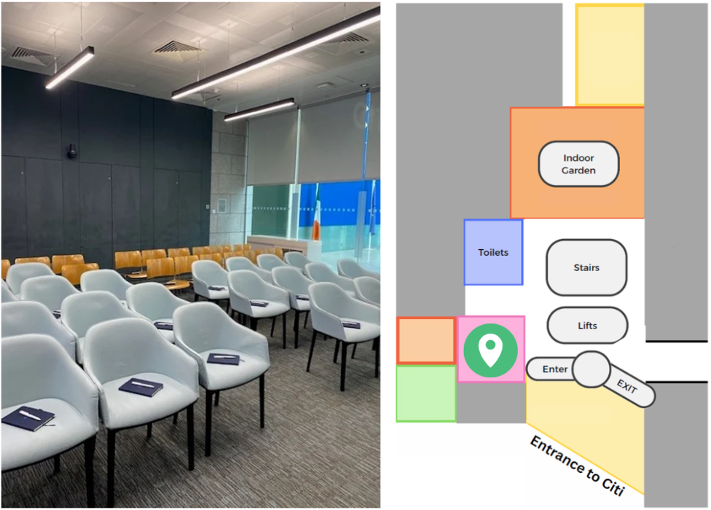
Welcome & Workshop Room

CV Clinic Room
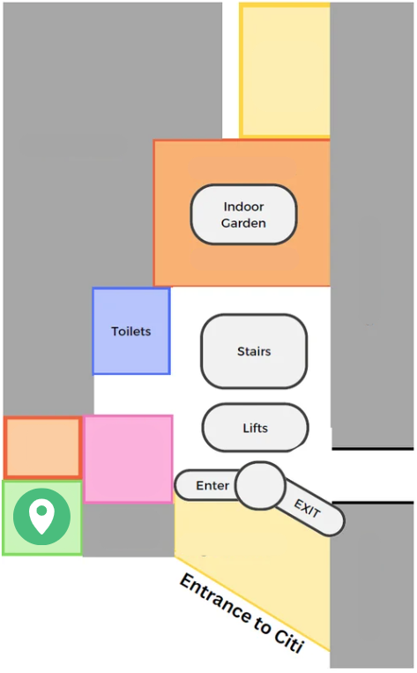
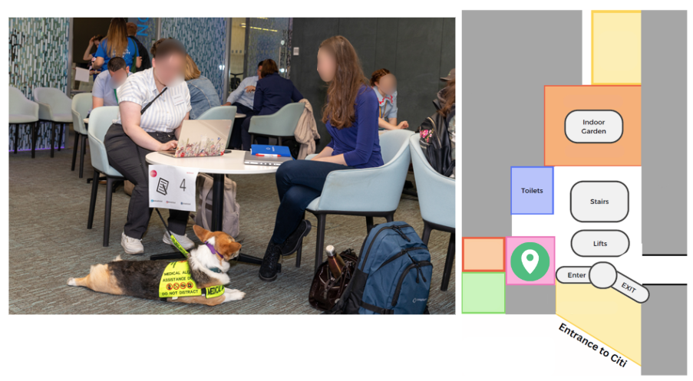
The same room used for the welcome and workshops will then be flipped into the CV Clinic room, which will be set up with tables and chairs as shown below:

Quiet Room
You can access this room through the Welcome/Workshop/CV Clinic room as shown on the map to the left:

Get-A-Headshot Room
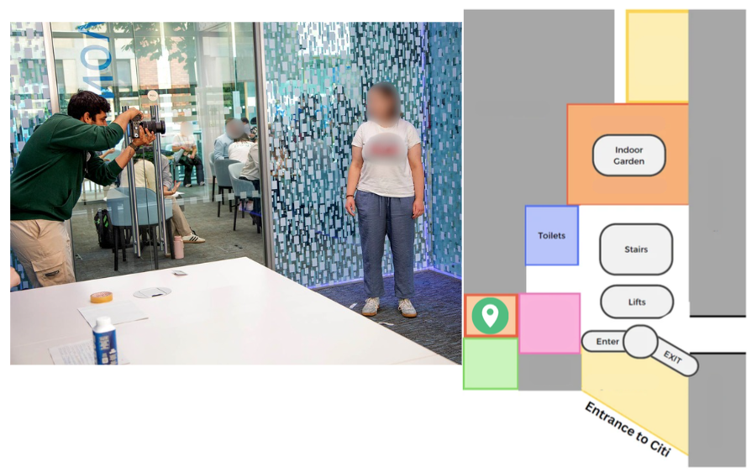
You will also access this room through the Welcome/Workshop/CV Clinic room.
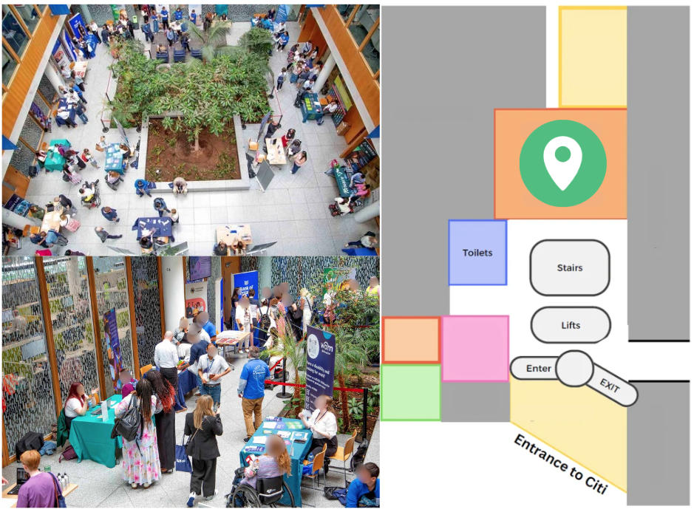
Exhibition Area/Employer Stands
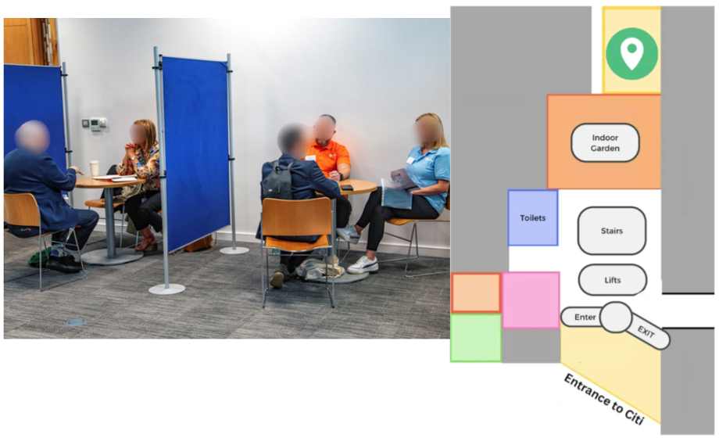
Mock Interview Room

