AHEAD Annual Conference: Travel Guide

Croke Park Conference Centre is located 5 minutes from Dublin City Centre and a 25 minutes’ drive from Dublin Airport. To help you find your way to the venue below is a guide on some of the local transport routes available to you.

  - 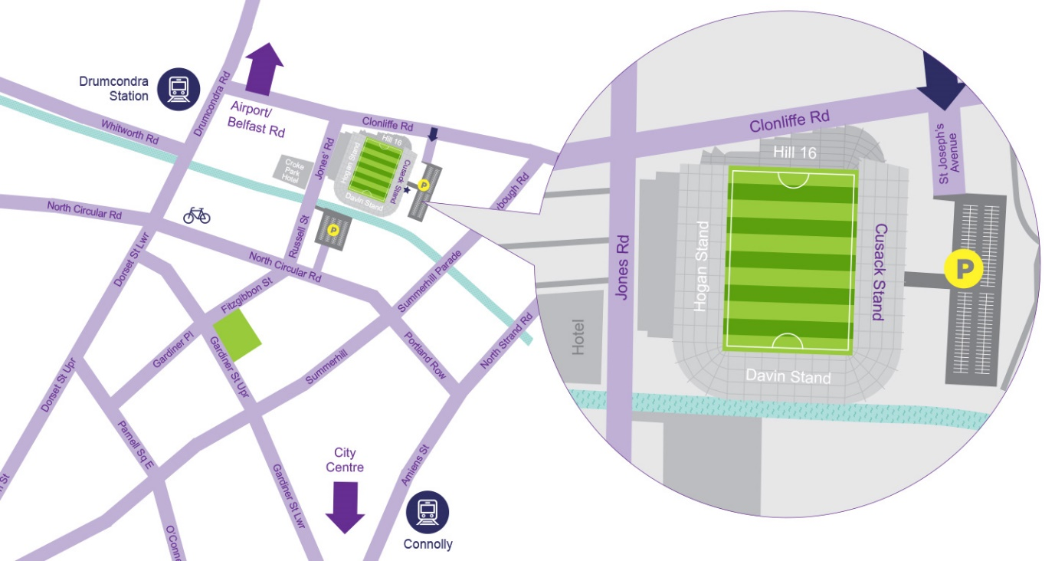
Croke Park

On foot
Croke Park is just a 20 minute journey from the City Centre. Click here to navigate via Google Maps to the location. You can view the walking map to the venue here.

By car
There is free parking available at the venue which is accessible via Jones Road.
Figure 2 Croke Park Car Park
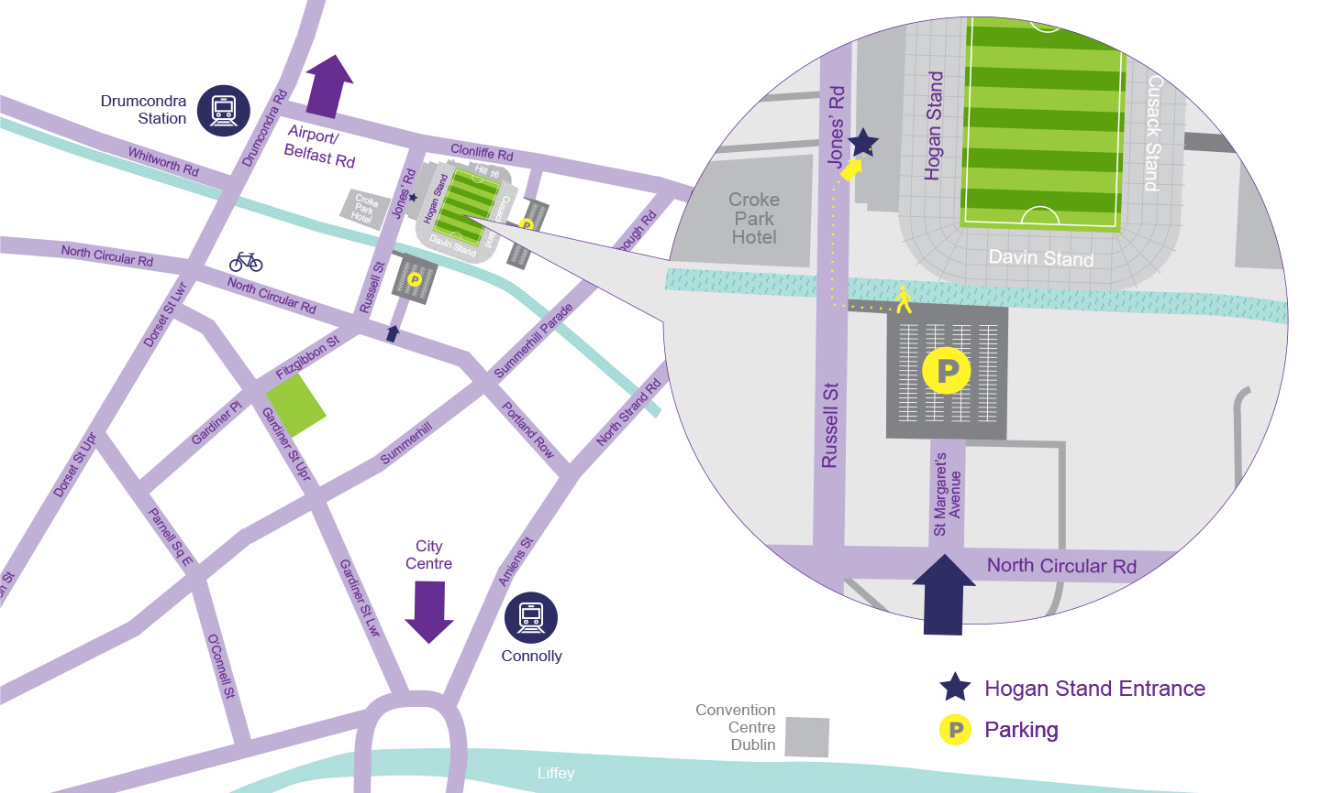

We have limited availability to disabled car parking spaces closer to the venue. Should anyone need to avail of these for the event please contact Christine at Christine.hynes@ahead.ie by 1pm (GMT) Friday 15th March 2019

By train
The closest railway station is Drumcondra at the intersection of Drumcondra Road (N1) and Clonliffe Road, is a 5 minute journey from the stadium. The closest DART stations are Connolly and Clontarf. Connolly is a 15-20 minute walk and Clontarf a 25 minute walk to the stadium.
For further information on accessibility, Irish Rail requires advance notice for any wheelchair users of their journey. Please click here for more information. Also you can book tickets online on their website available here.

By bus
Figure 3 Dublin Bus
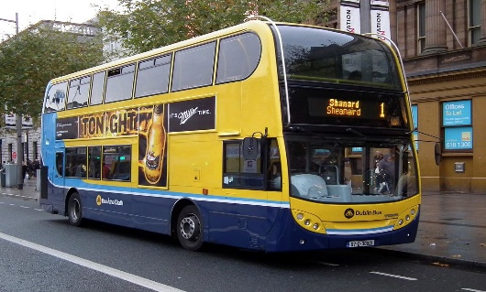
Dublin Bus offers a high-frequency, accessible and easy to use service from all over Dublin. A number of services bring you quite close to Croke Park and many others will get you to the city centre from where the stadium is a 15 minute walk.
*Please note that you will need exact change or a Leap Card when using Dublin Bus.*

Bus Routes that serve Croke Park
1, 7, 11, 13, 14, 16, 27a, 27b, 29a, 31/a, 31b, 32, 33, 40, 40b, 40d, 41, 41b, 41c, 42, 43, 44, 53, 123, 13
For further information, including to read the accessibility options available with Dublin Bus please click here.

Bus Routes from the airport
Figure 4 700 Airport-Dublin City Centre Bus
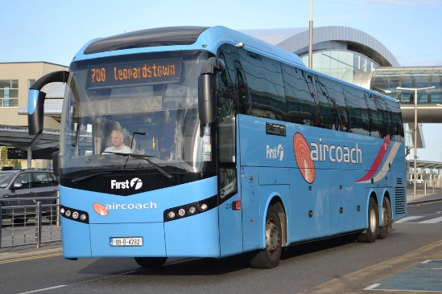
Croke Park is 15 minutes from Dublin Airport however depending on the time of day you are travelling this can vary due to traffic congestion. Please click here to search the transport options from Dublin Airport to Croke Park.

By bike
Figure 6 Dublin Bikes
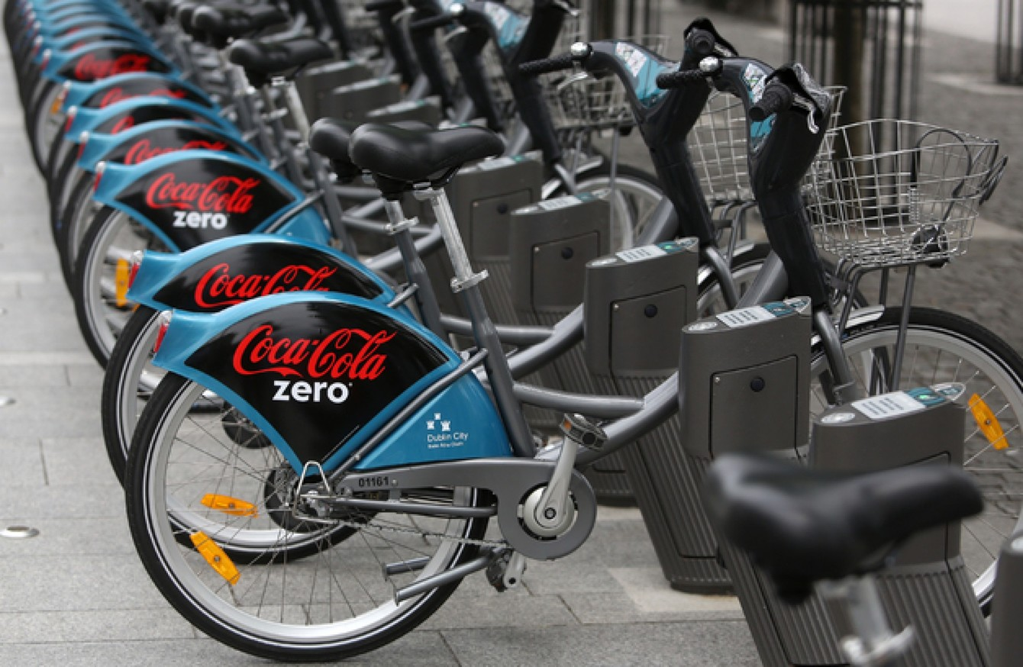

Croke Park is just a cycle from the City Centre. There is a public bike scheme Dublin Bikes, where you can rent a bike, have self-service stations located across the city centre. For more information on the service please click here. The nearest Dublin Bike stations are located on North Circular Road at Mountjoy Square. To map of all available stations to pick up and drop a bike is available here.

By Luas
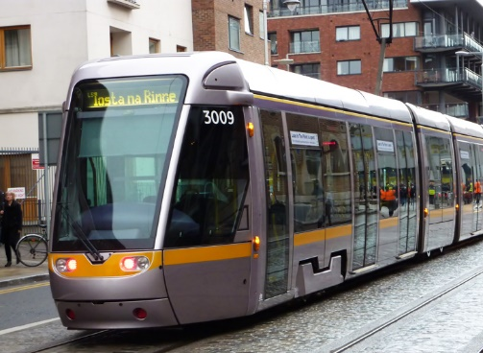
Take the Luas Red Line to Connolly Station and Croke Park is just a 20 minute walk.

By Taxi
There are a large number of taxi services available in Dublin. Taxis from the airport to the city centre are readily available outside the Arrivals Hall. Please ensure to only travel in a registered taxi – they will have their taxi license displayed on the dashboard.
Taxis are readily available all over the city with listed Taxi ranks in most main tourism areas or can be ordered at The Croke Park Conference Centre or hotel receptions.
Croke Park Stadium also provide a useful public transport guide with maps on transport link. This guide can be access here.

