# **Sean T. Special School to Day Services – My Story**

**My name is Sean, I went to St Joseph’s Special School in Waterford.**

|  |  |
| --- | --- |
| No photo description available. |  |

**After School I went to Start for three years.**

|  |  |
| --- | --- |
| Home - Brothers of Charity South-East  **START – Nova Services**  **Rehabilitative Training** | **START** – is a Rehabilitative Training Centre. It focuses on facilitating trainees to make a successful transition from dependence to greater independence and occupational integration. The programme runs for three years and caters for people who have the potential to maximise their independence skills. It aims to provide trainees with skills, knowledge, attitude and experience for a successful progression into part time employment, further education or an alternative day service based on the need of the individual.  START also aims to provide trainees with necessary skills to cultivate social gain, skills to achieve the highest possible level of personal health and also self-advocacy skills to empower trainees in negotiating their own development within the community. |

**In Start we learned about computers, getting around town, money and did lots of sport and activities. We had Literacy classes in our Centre, and I did Reading and Writing level 2.**

|  |  |  |  |
| --- | --- | --- | --- |
| Personal Computer - Vision Ireland | Subsidised Leap card for workers among pilot schemes to encourage people to  use public transport |  | Home - Waterford and Wexford Education and Training Board |

**During Covid 19, we needed to stay at home. I did an online course called the Ability Program through DCU and we learned about working and getting ready for work.**

|  |
| --- |
|  |

**In my final year at START, I went to Ozanam Street FET Centre for Art Classes with Community Education. We celebrated Learner Week and made Chinese lanterns.**

|  |  |
| --- | --- |
|  |  |

**After START, I went on to Brothers of Charity Tory Services - Pathfinders.**

|  |  |
| --- | --- |
| Home - Brothers of Charity South-East  **Pathfinders**  **Tory Services** | Tory Pathfinders services in Waterford endeavour to support people to participate in their local communities and to avail of all the opportunities available to them in these communities. This can take the form of joining adult education classes for example literacy, cooking, IT; entering into employment – either paid or in a voluntary capacity; participating in community groups like Tidy Towns, Waterford Walls, SPRAOI, St Patrick’s Day Parades; beach clean ups and The Men’s Shed amongst others. People we support have the opportunity to participate in social farming, gain skills in enterprises which may lead to employment in the open market, join in arts groups, musical groups, participate with the Special Olympics, join in all the fun and frolics with our own recreation department in addition to accessing sports venues across the city and county. |

**I went to LATCH ON course on Mondays and Wednesdays in St Patricks Gateway.** **I went to the National FET Learner Forum and celebrated World Down Syndrome Day with my class.**

|  |  |  |
| --- | --- | --- |
|  |  |  |

**We do lots of Sports, Voluntary work and short courses with Community Education in Pathfinders.**

**I did First Aid and Fire safety and Mai Thai self-defence.**

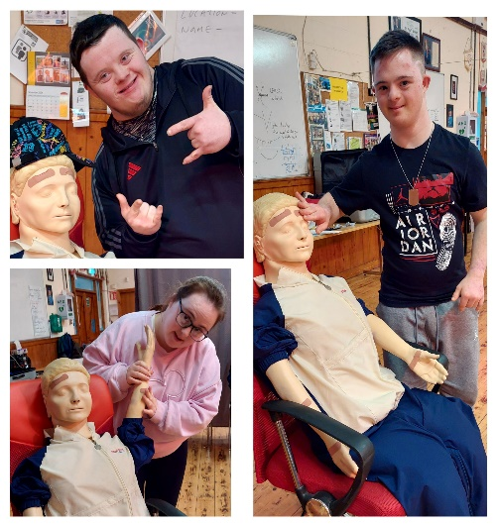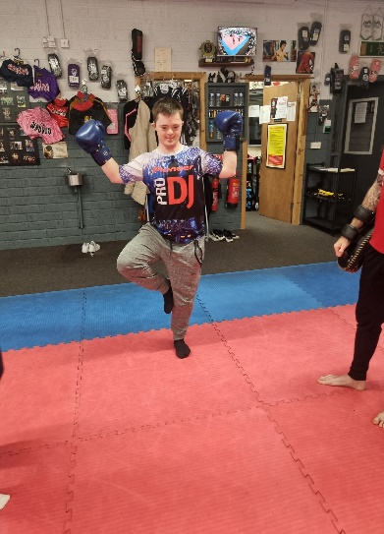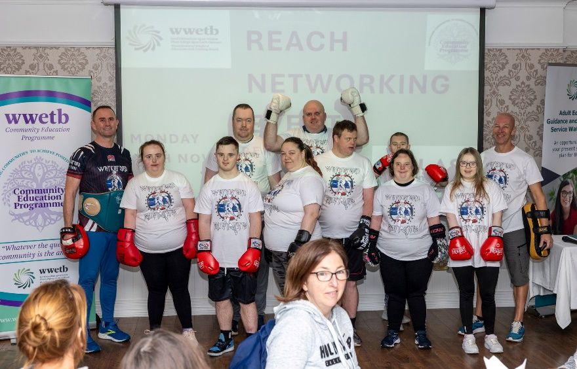

**Internet and Online Safety and Cyber bullying**

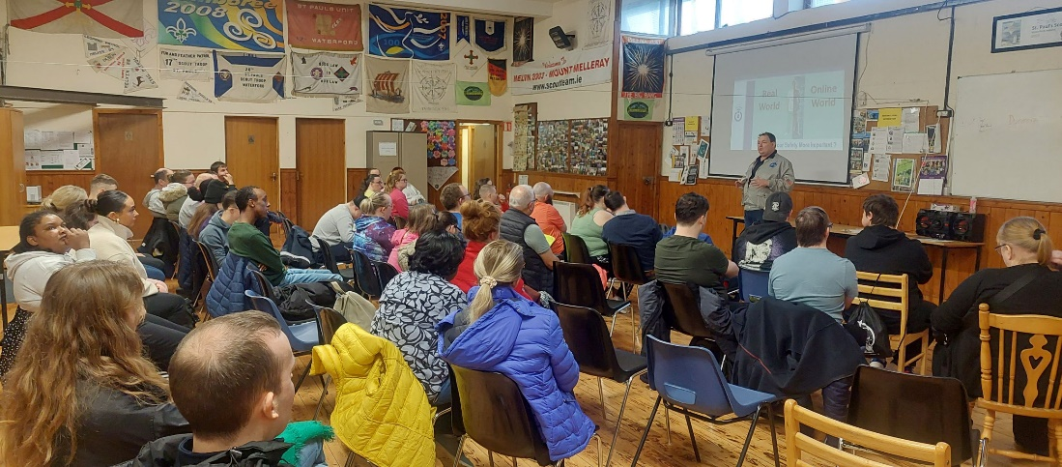

**Gardening and volunteering in the local community with the residents association.**

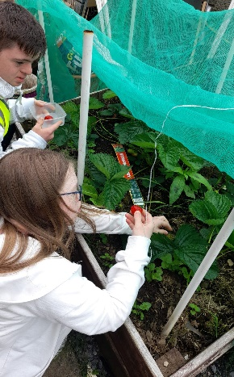 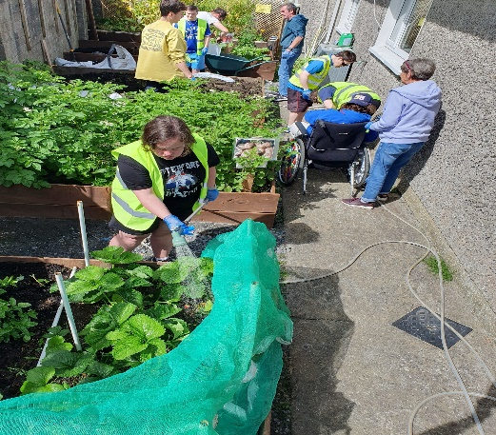 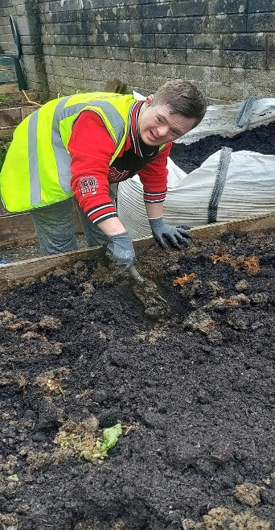

**I volunteer in the allotment and the Community gardens and social enterprise.**

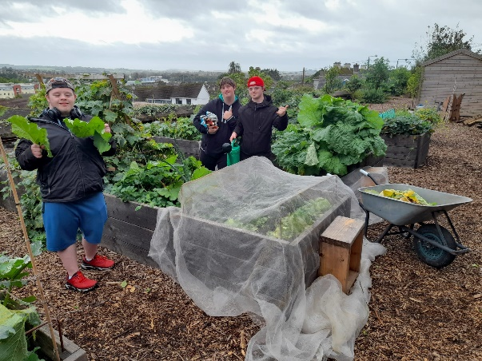 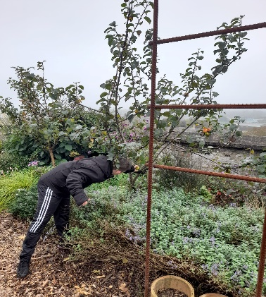

**We did Water Safety**

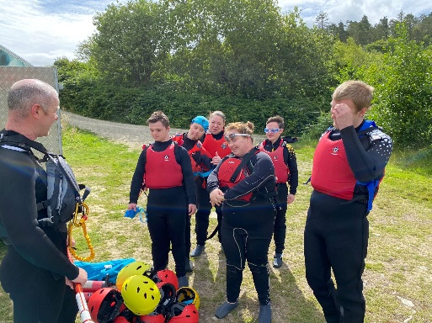 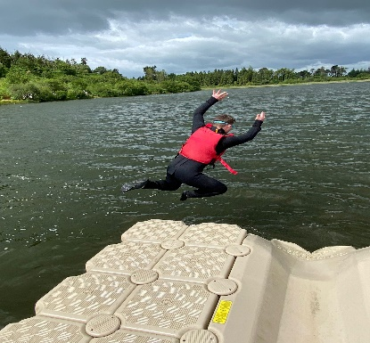

**I did a course in Barista Training Skills level 2 course and did a work placement in Top of the City Community Gardens & Social Enterprise and Lucas’ coffee shop.**

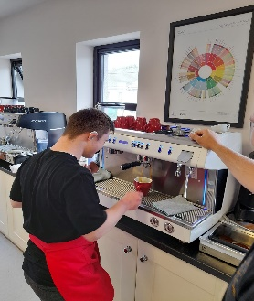 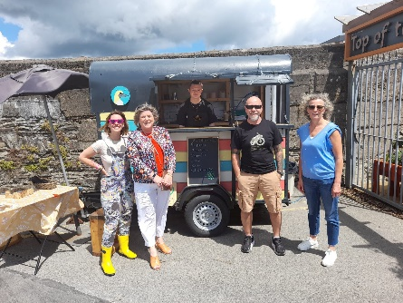

**

**I have an Employment support worker in Brothers of Charity. I did interview skills training with Down Syndrome Ireland.**

|  |  |
| --- | --- |
|  | **Employment**  **Support Officer**  **Brothers of Charity**  Home - Brothers of Charity South-East |

**I am now on work experience at Moes restaurant. I received Employee of the month award for my work.**

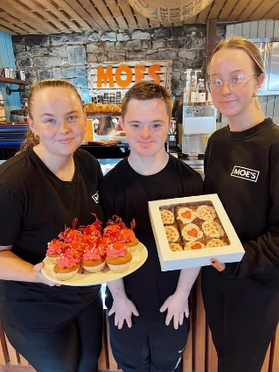 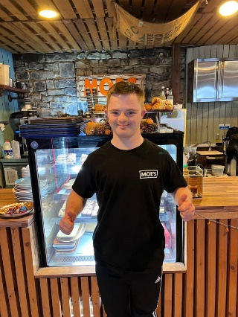

**I am working on my independent travel with Bus Eireann to get to my work placement**

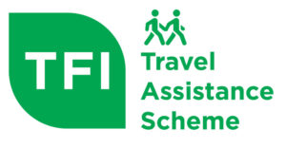 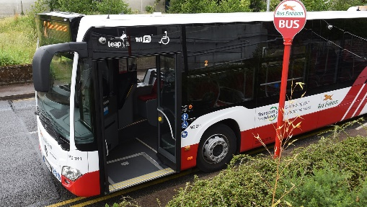

**My Day Service is linked to Waterford Special Olympics.**

**I do lots of Sports with Special Olympics, Soccer, Basketball, Gymnastics, Badminton, Bowling.**

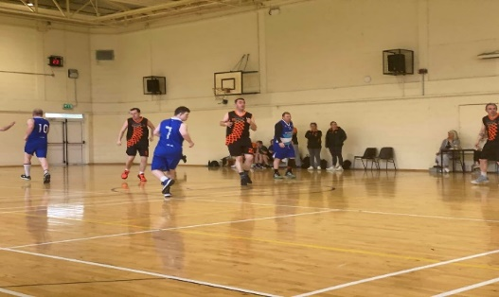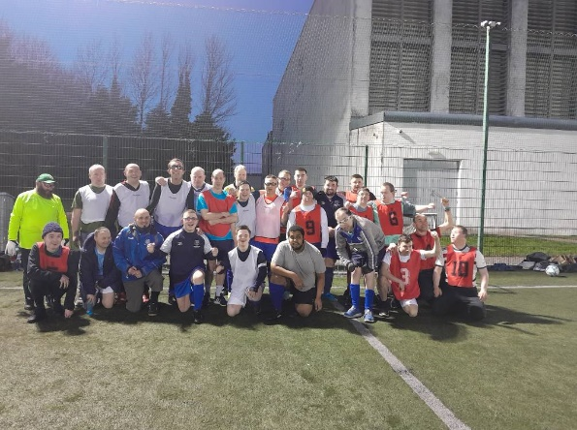

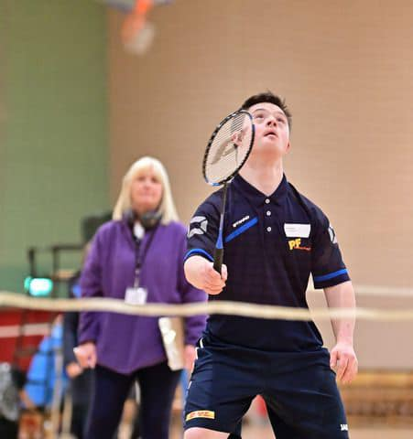 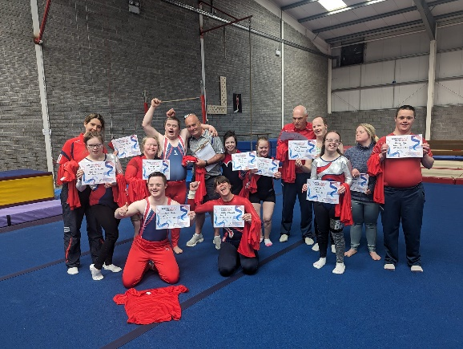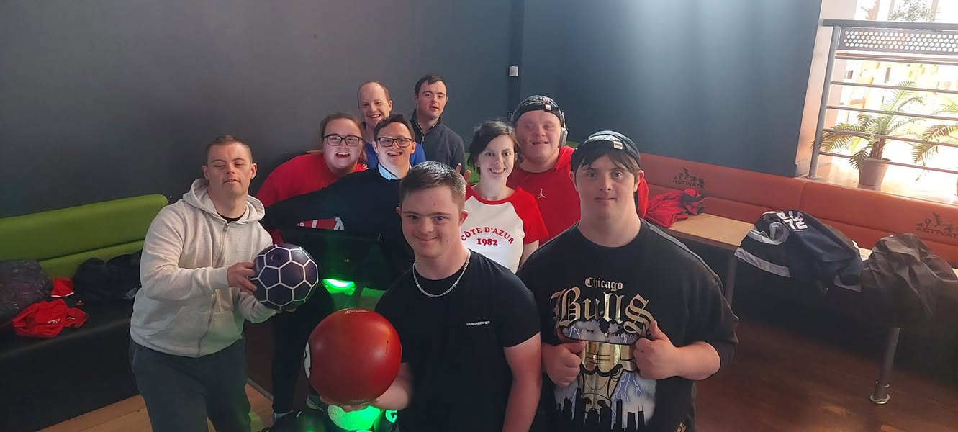

**I play for Bohemians Football Club Football for All and Cork City Down Syndrome Futsal Team.**

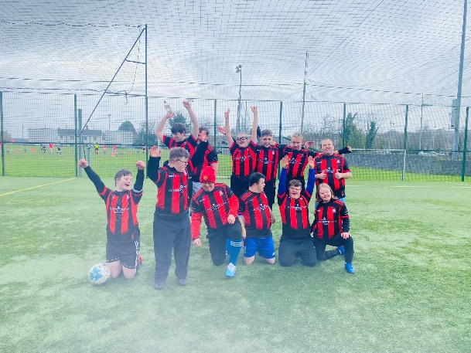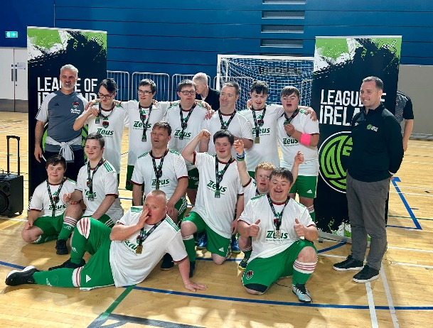

**I also play Futsal for Ireland.**

