How do I change my PowerPoint into a Video?

Tell me more!
So, you have a completed PowerPoint presentation and you want to turn it into a video with narration? Well you’re reding the right document to help you. Just follow the simple instructions below and you can convert your great presentation into an amazing video.

Where do I begin?
- Open your PowerPoint Presentation.
- Then click on the ‘File’ Tab.
- Go to ‘Export’ option and click on it.
- Now click on ‘Create a Video’.

There are 2 options here:
- Choose ‘Full HD’ to create a high-quality video. (You can choose lower qualities by clicking on the drop-down arrow on the box’)
- In the next box you must click on the drop-down arrow and select the option ‘Record Timings and Narrations’.

You’re doing great!
Immediately your Presentation will be displayed in a new screen with controls for recording as well as more options. It should look like this screenshot below.
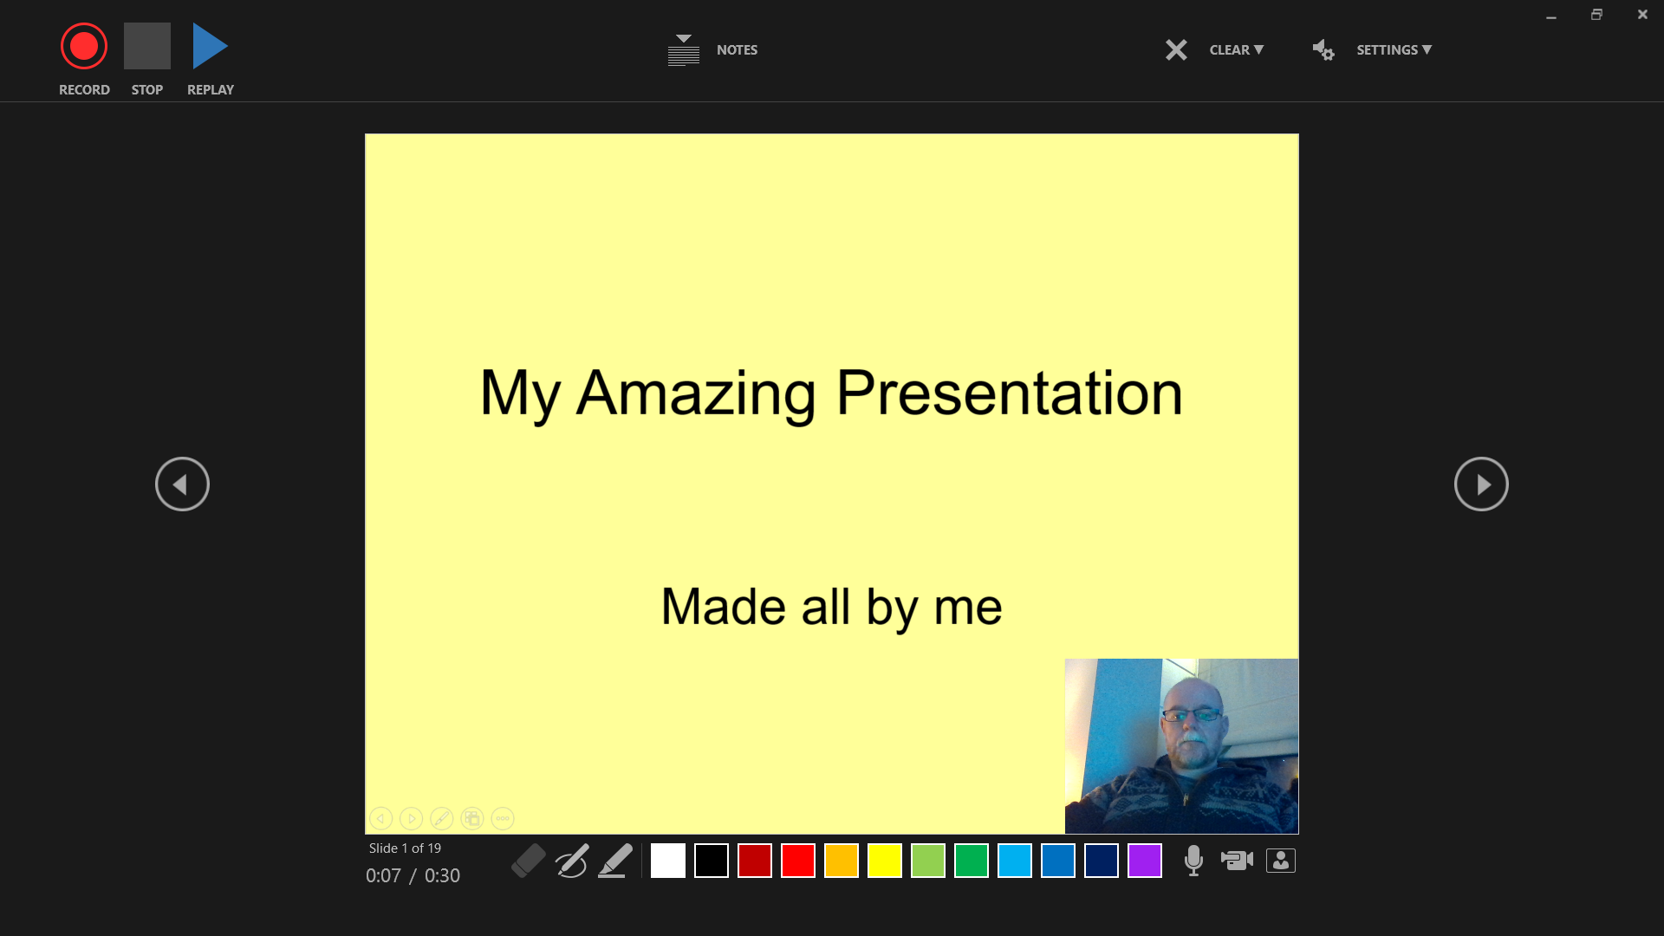
When you see this screen, you are almost ready to record. There are a few small decisions to make now.
- Do you want to see a small video of yourself on the bottom right corner of the screen? If yes, then click on this icon in the bottom left of the screen.

- If you want to prepare notes for each slide, then click on ‘Notes’ in the top middle of the screen.

- When you are ready to go, press the round red record button in the top left of the screen.

- Just talk and now and it will be recorded.

- When you have finished speaking about your slide click on this button to move to the next slide.

- If you are unhappy with the narration just stop the recording and click on the ‘Clear’ button to retry the narration in one slide or all slides.

- Finally, along the bottom of the screen you have an eraser, pen and highlighter tools. Choose the pen colour by clicking on the pen and then on your desired colour. To choose your highlighter colour click on the highlighter and then your desired colour too.

- When you are finished, press ‘Stop’ and go to the top right of the screen and click on the ‘x’ to exit this screen.

- Then press the ‘Create Video’ button as seen below.
- Then name the video file and select which folder you want to place the video.

- Then click the ‘Save’ button.

Congratulations, you now have a video of your presentation.
More information about the recording tools in PowerPoint.
Contact Trevor Boland at Trevor.Boland@AHEAD.ie in AHEAD if you require further support.

