Power of Disability 2026: Nothing About Me Without Me
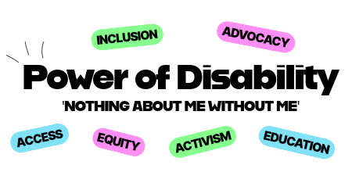
  - Participant Visual Guide and Info Pack
  - 11th April 2026, RCSI 118 Stephens Green and Online

Contents
About the Event 3
What is Power of Disability? 3
How can I attend the event? 3
Attending Power of Disability In-Person 4
Where is Power of Disability’s in person component? 4
How can I get there? 5
What will happen on the day? 5
Attending Power of Disability Online 7
How do I participate in Power of Disability online? 7
Agenda 8
Accessibility Information 10
Further Information 11

About the Event

What is Power of Disability?
Power of Disability is a conference for students with disabilities. It is organised by AHEAD, AMLÉ, and the Students with Disabilities Advisory Group. You can find more information on AHEAD, AMLÉ, and the advisory group on their websites.

The event is designed for and attended by higher education students and further education learners with disabilities. Participants will engage in sessions focused on succeeding in education, studying, and moving to graduate employment. They will also take part in a feedback workshop, telling AHEAD and AMLÉ about their experiences in education and the changes they would like to see in the education system. This guide is designed to give you a better understanding of what the event is, and what will happen on the day.

How can I attend the event?
To attend the event, you need to register for free on the Power of Disability Eventbrite. If you are attending in person, you need to have an in-person ticket.

Attending Power of Disability In-Person

Where is Power of Disability’s in person component?
Power of Disability will take place in RCSI, 118 Stephen’s Green in Dublin. The Eircode is D02 X0N1. The building faces Stephen’s Green park and the Green Line Luas.
When you enter the building, the event room is directly in front of you. It is called the Auditorium.
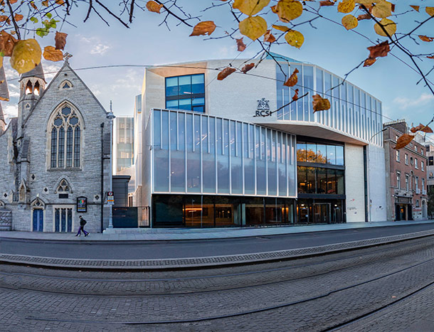
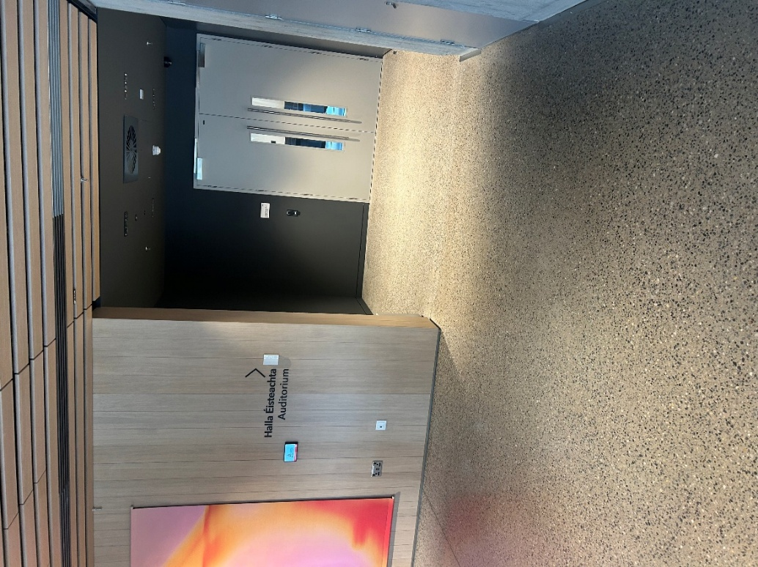

How can I get there?
The closest train stations to the venue are Pearse and Tara Street.
The nearest Luas stop is Stephen’s Green (Green Line).
Many bus routes go close to RCSI, such as those stopping on Dawson Street, Camden Street, Aungier Street, and Stephen’s Green.
There is limited parking near RCSI, including for those with disability parking permits.
The nearest car park is Q-Park St Stephen’s Green. This is a paid car park.

What will happen on the day?
We will be welcoming you to join us from 10am on Saturday 11th April.
Once you enter the building, you will see the Auditorium directly in front of you.
You will meet AHEAD staff here and they will check your name off a list.
The auditorium is a large, flat room. At Power of Disability, there will be fewer tables and chairs and more space to move around. There are bathrooms beside the Auditorium, and a quieter area you can go to if you need a break.
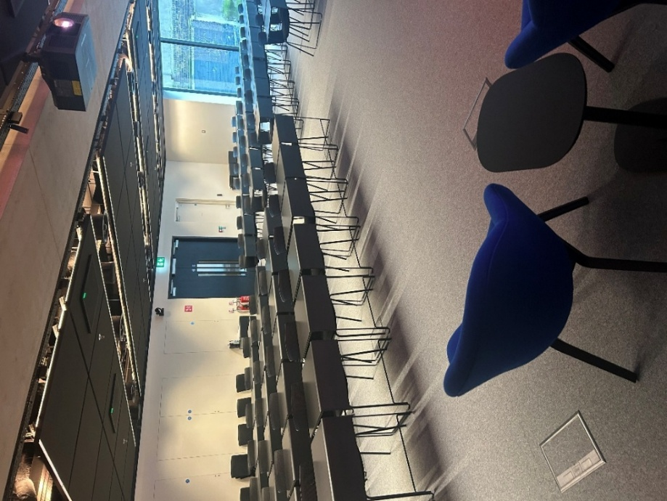
Before the event starts, you will have time to sit down and have a tea or coffee, if you’d like.
At 10:30 am the sessions will begin. There is more information on the sessions in the ‘Agenda’ section of this document. There are breaks built in to the agenda but you can move around and take breaks throughout the event.
During the information sessions in the morning, there will be opportunities to ask the speakers questions. You will be able to ask questions out loud or online using Slido. There will be a QR code you can scan to submit questions on Slido.
There will be a lunch break from 1:15pm to 2:15pm. Lunch will be provided at the event. This will be sandwiches. Make sure to tell us when you register on Eventbrite if you have any dietary requirements so that we can make sure to accommodate them. There is also a coffee shop in the building that you can go to, if you want.
In the afternoon, you will get to chat about education with other students in small groups. There will be a member of the Students with Disabilities Advisory Group in each breakout group, and they’ll help to start and lead the conversations. Some students will give feedback from their group to everyone at the event, but you don’t have to do this if you don’t want to do.
After this workshop, we will have some coffee and cookies and do a quiz. The quiz will be in the same groups you were in for the workshop, so you will have already met the other people. The quiz will be a relaxed activity and will last for about 45 minutes. You’ll be able to chat to the other students at the event, if you’d like to. You don’t have to go to this session if you don’t want to.
The event will be finished at 4:30pm.

Attending Power of Disability Online

How do I participate in Power of Disability online?
The zoom link for Power of Disability will be sent to the email you use to sign up with before the day of the event.
Power of Disability will run online from 10:30 am to 1:30 pm. If you attend online, you will listen to the keynote speaker and then participate in three sessions. There is more information on these sessions in the ‘Agenda’ section of this document. After these sessions, there will be a closing speaker to recap the main points we have discussed and to thank you for attending.
You will be able to share your thoughts and ask questions using an online tool called Slido. A link and a QR code to access the Slido will be shared at the event. You will not need to log in or sign up, you can just type your messages or questions on Slido.

Agenda
10:30 – 10:45: Keynote Speaker
There will be a short speech to open the event. The keynote speaker has not been announced yet. You’ll be able to find more information soon on the Power of Disability website.
10:45 – 11:15: Students with Disabilities Advisory Group Panel
The Students with Disabilities Advisory Group will tell you a little about their experiences in education, and what works well for them. They will answer a few questions from participants.
11:15 – 11:30: Break
11:30 – 12:15: Studying as a Student with a Disability
There will be three lightning talks on different topics – what disability support services can do for students, assistive technology, and a student with a disability’s experience of studying
Students will get a chance to share any tips they have for academic success, if they’d like to.
12:15 – 12:30: Break
12:30 – 13:15: Graduate Careers Session
There will be a presentation giving you some information about moving towards graduate employment. Then, a panel of graduates with disabilities will share some insights with you. They will answer some questions from participants.
13:15 – 14:15: Online Closing and Lunch
14:15 – 15:30: Student Voice Workshop (In Person Only)
You’ll hear a short presentation about students with disabilities’ rights in education. AHEAD and AMLÉ will tell you a little bit about the work they do for disabled students.
Then, we will break participants up into smaller groups. The groups will discuss what education looks like for students with disabilities now, and how it could change for the better. There will be a member of the Students with Disabilities Advisory Group in each small group to help get the discussion started.
After the discussion, one or two people from each group will share what they discussed with the group. Staff from AHEAD and AMLÉ will listen to what students have to say so that they can learn from them.
15:30 – 16:30: Quiz (In Person Only - Just for Fun!)
After all the sessions, there will be a quiz in the small groups. This will be relaxed and you’ll have a chance to chat to other students, if you’d like. This activity will last for around 45 minutes, and we’ll have some cookies and prizes for the winners. You don’t have to attend this activity if you don’t want to.

Accessibility Information
RCSI 118 Stephen’s Green is wheelchair accessible. The event is on the ground floor and there are no steps. There is a power assist door to enter the building.
There are toilets, including accessible toilets, beside the Auditorium. There is a changing place bathroom in the building. If you need this facility, please ask the AHEAD staff and they will show it to you.
There is a quiet space outside the event space, where participants can take a break at any point. You can move around throughout the event if you’d like to.
ISL interpretation is planned for this event, subject to interpreter availability. Captions will be provided throughout the event.
All slides will be accessibility checked and will be available online before the event.
Information sessions will be recorded and uploaded to YouTube after the event, with captions.

Further Information
If you have any questions or need any further information about the event, you can contact Cara Clarke, Student Engagement Officer at AHEAD
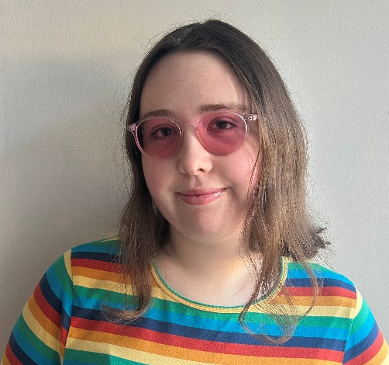
Cara’s email address is cara.clarke@ahead.ie

You can also find more information on the Power of Disability 2026 website

If you have any questions on the day, you can ask the AHEAD staff and they will be happy to help!

We look forward to seeing you at Power of Disability!

