
Candidate
Information
Booklet
Willing Able Mentoring (WAM) Programme 2027
Civil Service WAM Placements
AHEAD

Closing Date: 12pm Wednesday, 7th October 2026
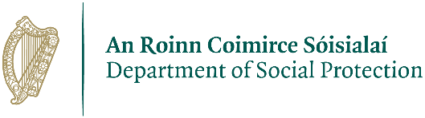
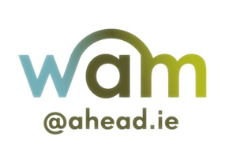


Recruitment Campaign for appointment to:

Civil Service WAM Placement 2027
Executive Officer Level Roles

Campaign Overview
Civil Service WAM placements are specifically for disabled graduates. The recruitment campaign for the Civil Service WAM Placements is co-managed by AHEAD and publicjobs. Further details about each organisation and the current campaign are found throughout this document. Contact details for each organisation are listed below.
Vacancy ID: 9037

Important Contact Details
Contact details for each co-managing organisation are listed below.
publicjobs
Contact email: Megan.Keane@publicjobs.ie
Phone: 01 858 7488
URL: www.publicjobs.ie
publicjobs is committed to a policy of equal opportunity and encourage applications under all nine grounds of the employment equality act.
publicjobs will run this competition in compliance with the Code of Practice for Appointment to Positions in the Civil Service and Public Service, prepared by the Commission for Public Service Appointments (CPSA) and available on CPSA - Commission for Public Service Appointments
publicjobs refers to Public Appointments Service established under the Public Service Management (Recruitment and Appointments) Act 2004-2013

AHEAD / WAM Programme
Contact email: wam@ahead.ie
Phone: +353 1 592 3667
URL: www.ahead.ie/wam

Table of Contents

Civil Service WAM Placement 2027 2
Campaign Overview 2
Vacancy ID 2
Important Contact Details 2
Key Information & Dates 5
Timeline for Recruitment 5
About the Civil Service & the WAM Programme 6
Overview of the Civil Service 6
Who are publicjobs? 6
What is The WAM Programme? 6
Civil Service Permanency Pathway for Eligible WAM Graduates 7
The Role 8
Overview of Key Duties & Responsibilities 8
Essential Requirements of the Role 9
Placement Location 10
Working Environment 10
The Competition Process 11
Stage 1: Application 11
How to Apply via the WAMWorks Database 11
How to Apply via publicjobs 12
A Note on Communication from publicjobs 14
Reasonable Accommodations for Recruitment 14
WAM Programme 14
publicjobs 14
Stage 2: Shortlisting 16
Stage 3: Interview 16
Stage 4: Allocation from Panel to WAM Placement 17
Stage 5: Pre-Employment Checks & AHEAD Needs Assessment 18
General Information 18
Review & Complaints Process 19
Recruitment & Selection – publicjobs 19
Requesting a Review under Section 7 19
Making a Complaint under Section 8 20
Requests for Feedback/Test Rechecks 21
Placement Allocation & Needs Assessment – AHEAD 22
Contact Details 22
Appendix 1: Application Checklist 24
Step 1: Register on the WAMWorks Database 24
Step 2: Complete and Submit the Civil Service WAM 2027 Application Form 24
Step 3: Create a publicjobs Account (New Users Only) 24
Step 4: Complete and Submit your publicjobs Application Form 24
Appendix 2: Registering with WAMWorks and Submitting your Application 25
Appendix 3: Registering an Account and Applying via publicjobs.ie 30

Key Information & Dates
Salary: €38,803 per annum (equivalent to approximately €735 gross each week for 10-month placement)
Annual Leave: 23 days per annum on a pro-rata basis (equivalent to approximately 19 days for 10-month placement)
Hours of attendance: 41 hours and 15 minutes gross / 35 hours net per week
Principal Conditions of Service: Information on the Principal Conditions of Service applicable to the role is available here
Eligibility to Compete: Information on Eligibility to Compete and Certain Restrictions on Eligibility is available here
Placement Start Date: May 2027
Application Closing Date: 12pm Wednesday, 7th October 2026
Online Information Session: An online information session on how to apply for the Civil Service Willing Able Mentoring (WAM) Placements 2027 will take place on Monday 28th September from 12 – 1pm. This session will provide an overview of the competition, the steps involved in the recruitment process and guidance on how to fully apply. You can Register for the Civil Service WAM Placements 2027 Information Session here.

Timeline for Recruitment
Stage 1 – Application | Open from: Wednesday, 23rd September 2026  Closing Date: 12pm Wednesday, 7th October 2026
Information Session (online via Zoom) | Monday, 28th September 2026 – Please register for the information session here
Stage 2 - Shortlisting | October 2026
Stage 3 – Interview  (to be held remotely via Zoom) | November 2026
Stage 4 – Allocation from Panel to WAM Placement | From January 2027
Stage 5 – Pre-Employment Checks & WAM Needs Assessment | From January 2027
Placements Start | May 2027*  *Specific start dates will be confirmed for successful candidates at the time of placement assignment.
Please note these dates are provisional and are subject to change.
Candidates must be available to attend interview during the timeframe set out above.

About the Civil Service & the WAM Programme

Overview of the Civil Service
The Civil Service is a large complex organisation employing over 50,000 people in approximately 40 Government Departments and offices and a range of other bodies. Every day the Civil Service makes a vital contribution to Irish life, with a vision of inclusive, high quality and integrated service provision that meets the needs and improves the lives of the people of Ireland.
Everything the Civil Service does, from carrying out the work of Government to delivering frontline public services, impacts Ireland in some way. Further information about the Civil Service is accessible at gov.ie.
All Civil Service employers are committed to championing an inclusive and diverse workforce that reflects modern Ireland and its people, striving to create a culture where all staff have equal access to opportunity and feel comfortable and confident to be themselves at work.
The Civil Service WAM Placement Programme supports the Irish Government’s commitment to increasing the number of staff with disabilities in all Government departments. It also supports Pillar 2 of the National Human Rights Strategy for Disabled People – 2025-2030, which commits to maximising opportunities and access for disabled people to get meaningful work in the civil and public sector.

Who are publicjobs?
publicjobs is the centralised provider of recruitment, assessment and selection services for the Civil Service and public sector in Ireland. publicjobs also provide recruitment and consultancy services to local authorities, the Health Service Executive, An Garda Síochána and other public bodies.
publicjobs shortlists candidate applications and organise interviews to establish a panel of successful candidates that may be offered a 10-month Civil Service WAM Placement. Please note that success at interview with publicjobs does not guarantee an offer of a 10-month Civil Service WAM Placement and places offered will be subject to placements available.

What is The WAM Programme?
The WAM Programme is an initiative of AHEAD. AHEAD is an independent non-profit organisation that works with and for disabled people to shape inclusive and empowering environments in tertiary education and employment.
The central objective of WAM is to promote a more inclusive labour market for graduates with disabilities. This is achieved through the provision of paid and mentored work placements, which employers participating in WAM provide for graduates with disabilities. WAM seeks to provide career opportunities for disabled graduates and successful candidates must be willing and ready to undertake the full-time roles as offered through WAM.
For graduates, WAM offers valuable employment experience (relevant to qualifications) and assists in the development of social and networking skills. Furthermore, a WAM mentor will be assigned to each successful candidate who will provide ongoing support and guidance during the placement. All successful candidates will be assigned a mentor within the organisation that they are placed. WAM mentors are someone who works within the company but is not assigned as the graduate’s direct line-manager. Managers and mentors will receive Disability Awareness training prior to the 10-month Civil Service WAM Placement starting, where more information and guidelines will be provided.
More information about the WAM Programme is available on our website. Please ensure you read all of the WAM Rules & FAQs.
Please note that the WAM Programme is a project of AHEAD. WAM and AHEAD are used interchangeably throughout this document when referencing the staff/policy which supports the WAM Placements.

Civil Service Permanency Pathway for Eligible WAM Graduates
A paid and mentored 10-month Civil Service WAM Placement is presently available under the WAM Programme. In line with the commitment to increase the number of staff with disabilities, the Civil Service runs a separate permanency competition during this 10-month programme.
This separate competition is managed by publicjobs and is confined to those that commence (and subsequently successfully complete) their 10-month Civil Service WAM Placement commencing in May 2027. Under this competition, candidates can compete for a permanent position at Executive Officer level in the Civil Service organisation(s) where they completed their 10-month Civil Service WAM Placement.
Candidates will be expected to have consistent attendance during their 10-month Civil Service WAM Placement to ensure their Line Manager can fairly assess the candidate’s performance, level of competency in the job and suitability to progress to the confined competition.
It must be emphasised that completion of a 10-month Civil Service WAM Placement in the Civil Service does not guarantee a future offer of a permanent position with the Civil Service. Similarly, qualification and placement on a recruitment panel established from any future recruitment competition is not a guarantee of appointment to a permanent position. There is no guarantee of a permanent position with any of the Civil Service employers as a result of undertaking a 10-month Civil Service WAM Placement.
Further information regarding the pathway to permanency will be provided to eligible candidates once their placements have commenced.

The Role
All Civil Service WAM placements are considered General Executive Officer level posts.
The Executive Officer (EO) grade is the entry level to junior management in the Civil Service. EOs are employed in all government departments and offices and cover a wide range of roles and activities, including researching and drafting proposals relating to policy issues and legislation; acting as junior managers in Government Departments; being responsible for managing operations and, after some experience, large numbers of people and other resources; and dealing directly with the public in support of services provided to them by the Civil Service.
In recruiting Executive Officers, publicjobs is conscious of the fact that many of the senior positions in the Civil Service will, in time, be filled by people recruited at this level. For this reason, we look for people who show the potential to take on high level responsibilities in the management of public services and the analysis of public policy issues.
To be effective in the role of an Executive Officer in the Civil Service, candidates need to be:
- Interested in public affairs and committed to the concept of public service;
- Capable of planning and organising people and resources to meet goals, targets and objectives;
- Understanding and sensitive in dealing with others, and persuasive when communicating in general;
- Interested in making sure all tasks are completed to a very high standard;
- Willing to share ideas and information with people, with the purpose of achieving a particular result;
- Interested in working as part of a team;
- Capable of presenting written material in a clear, concise, comprehensive and convincing manner;
- Fully committed to achieving quality results;
- Capable of using initiative as and when appropriate;
- Able to conduct an in-depth review of intricate, non-routine subject areas and make appropriate recommendations.

Overview of Key Duties & Responsibilities
The specific duties of each EO role will largely be determined by the Civil Service organisation to which successful candidates are assigned. However, some duties and responsibilities are common to all EO roles, such as:
- Planning and organising people and resources to meet goals, targets and objectives.
- Presenting written material in a clear, concise, and comprehensive manner.
- Collating and examining information, identifying anomalies and making links to support the work of their team.
- Explaining complex information and interacting with the public/customers on schemes and services; potentially as part of service desk support.
- Conducting in-depth reviews of intricate and/or sensitive information and make appropriate recommendations.
- Taking ownership to ensure issues are resolved or escalated in a timely manner.
- Playing an active role on the team and participating effectively as a team member in pursuit of team goals.
- Collaborating effectively with other teams and business units in your organisation to ensure the delivery of high-quality work in a timely manner.
- Supervising, training and co-ordinating of staff.
- Supporting/standing in for their Line Manager as required.
- Carrying out any other duties relevant to the role which may be identified from time to time.
The above job description is a guide to the general range of duties of the successful candidate. It is not intended to be definitive or restrictive.

Essential Requirements of the Role
Candidates must, at the time of submitting their application (no later than 7th October 2026):
- Have a disability
- Have achieved a qualification at minimum Level 6 on the National Framework of Qualifications (NFQ) (or NARIC Ireland Foreign Qualifications equivalent).
- Meet the eligibility criteria to compete which is detailed in the Eligibility to Compete and Certain Restrictions on Eligibility document
- Have the knowledge and ability to discharge the duties of the post concerned and have relevant skills such as IT and Administration.
- Be able to demonstrate the capabilities identified as necessary for the role as outlined in the Capability Framework for the role of EO in the Civil Service.

Candidates must also:
- Be available and ready to undertake a full-time, 10-month Civil Service WAM Placements in May 2027.
- Fulfil Health & Character, Garda Vetting & Security Clearance and Reference Check requirements – further information on publicjobs Pre-Employment Checks is contained in the publicjobs General Information document.

Candidates must not:
- Currently be employed in the Civil Service in a permanent capacity.
- Have undertaken a previous Civil Service WAM Placement since 2022.
Please note: Qualifications/eligibility may not be confirmed until the final stage of the process, therefore, those candidates who do not possess the essential requirements, on or by the dates as specified, and proceed with their application are putting themselves to unnecessary effort/expense and will not be offered a position from this competition.
The onus is on the candidate to ensure they fulfil the eligibility requirements as set out. publicjobs reserves the right to deem an applicant ineligible at any stage if it is apparent that the candidate does not hold the required eligibility/qualifications from the submitted application form. Candidates who are unable to demonstrate that they hold/will hold the required qualification(s) by the deadline specified may be withdrawn from the competition at any stage. An invitation to tests, interview or any element of the selection process is not acceptance of eligibility.
Candidates who are placed on a panel and come under consideration for a position will be required to provide documentary evidence of their eligibility, including proof of qualification. Please be aware a transcript of results may be required; therefore, the responsibility is on candidates to have this information available if requested by publicjobs.
All role offers are subject to completion of a full clearance process through publicjobs and successful completion of a WAM needs assessment with AHEAD.

Placement Location
Candidates who are successful in this competition will be placed on a panel in order of merit, from which placement opportunities arising across the Civil Service will be filled. Opportunities may arise in any of the Government Departments/Offices participating in this programme. While the majority of placements are expected to be located in the wider Dublin area, a limited number of placements will also be available in some regional locations. Applicants will be given an opportunity to indicate their interest in regional locations on the AHEAD application form.
There are a limited number of 10-month placements on offer; therefore, it may not be possible to offer a placement to all successful candidates.

Working Environment
The Civil Service has developed a Blended Working Policy Framework for Civil Service Organisations. Please note, any blended/hybrid working arrangements are subject to role suitability and the business needs of the organisation. More information on the specific working arrangements for each placement will be provided on allocation.

The Competition Process
The Competition Process for the Civil Service WAM Placements 2027 will consist of several separate stages. Please refer to the Timeline for Recruitment table on page 5 for expected dates of each stage.
Please read and follow the step-by-step instructions carefully to ensure your application is submitted correctly to both AHEAD and publicjobs.

Stage 1: Application
Interested candidates must:
- Register an account on AHEAD’s WAMWorks Database and then
  - Upload and submit a fully completed Civil Service WAM 2027 Application Form, which is available from AHEAD’s website (www.ahead.ie/csplacements), by 12pm Wednesday, 7th October 2026.
- Fully apply online to publicjobs at this link by 12pm Wednesday, 7th October 2026.
Please note: An ‘application checklist’ can be found in Appendix 1 at the end of this information booklet. This checklist outlines the detailed steps required for complete application. Please review this list to ensure that you have appropriately completed all necessary application steps.

How to Apply via the WAMWorks Database
Applications should be made online via the WAMWorks Database.
If you do not already have a WAMWorks account, you will need to register for a new one by selecting the option to create a new account. During the registration process, you will be asked to select your Disability Status and provide some personal information. Please complete all required fields and then select “Create New Account” at the bottom of the page. Please note, you must have a disability to register with WAMWorks and apply for a WAM Placement. If you are unsure if you qualify, please reach out to a member of the WAM Team at WAM@ahead.ie for more information. You can also review the WAM eligibility criteria on the AHEAD website.
Once you have created your account, log into WAMWorks using your registered email address and password. Before starting your application, please check that the information in your profile is complete, correct and up to date. You should then select “Civil Service: Executive Officer Roles” from the list of available placements.
You will also be asked to upload your completed Civil Service WAM Placement 2027 Application Form. To do this select “choose file”, locate the completed application form on your device and select “open”. Before continuing, check that you have selected the correct and final version of your application form. You must then select “upload document” to upload a copy to WAMWorks. Simply choosing the file does not upload it. When the document has been uploaded successfully, a message will appear reminding you to complete the remaining application information.
Please note, CVs will not be accepted as application to this role. You must upload a fully completed application form. Incomplete applications and applications submitted using a CV will not be considered.
After uploading your application form, select your placement preference, check that your contact details are correct and answer all placement-specific questions. Review the information you have input carefully before submitting your application. When you are satisfied that everything is complete and correct, select “confirm details and submit application” at the bottom of the page.
Once you have clicked “confirm details and submit application”, a message will appear asking you to confirm that you wish to submit your application. If you are ready to proceed, select the red “Yes, submit application” button.
When your application has been submitted successfully, a confirmation message will appear on the screen. You will also receive an email confirming that your application has been received.
Your application is not complete until you have selected “Yes, submit application” and received confirmation that it has been successfully submitted. If you have any queries regarding the WAMWorks application process, or if you are unsure your application has been successfully submitted, you can contact the WAM Team via email (wam@ahead.ie) or by calling us at +353 1 592 3667.
A step-by-step guide (with screenshot images) on how to register/apply via WAMWorks is available in Appendix 2 of this document.

How to Apply via publicjobs
Applications should be made online through the publicjobs application portal.
At publicjobs, have transitioned to a new recruitment platform with the aim of enhancing their services and the candidate experience. The new service will give you more visibility and control of your application.
When accessing the new recruitment platform for the first time, candidates must register as a New User to create a profile (“Register”). To do so, please access the vacancy you wish to apply for on the Jobs Board by clicking on the title of the position. You will be brought to the vacancy where you can click on “Apply” in the right-hand section of the website, or at the bottom of the advertisement. Candidates who have not previously registered on the new recruitment platform will be required to enter some personal details to continue with their application. Account verification will be required, and you must check your email inbox and follow the instructions to verify your account. Please do not confuse registering (creating a profile) with applying.
Candidates who have already registered will have an account and should select ‘Login’ from the top right-hand section of the registration page or through the link at the bottom of the page.
Once registered and after your email address has been verified, you must then access the application form, ensure all sections of the application form are fully completed and submit it.
To do this, you will be required to return to the vacancy you wish to apply for – Willing Able Mentoring (WAM) Programme 2027 - on the jobs board on publicjobs Application Portal and click on “Apply”. This time, you should select the “Login” option in the top right-hand section of the Login Page. Your username is the e-mail address associated with your account. Please note that your username and password are case sensitive.
Please carefully note the following instructions:
- As you progress through the application, at the bottom of every page, there will be an option to “Save and Continue”.
- The information that you enter is only saved once you click on the 'Save and Continue' button.
- If you close the browser before clicking 'Save and Continue' or are inactive on the system for 30 minutes or more, you may be logged out of the application form and your information could be lost.
It is imperative that all sections of this application form are completed in full. The mandatory fields are marked with an asterisk *. These fields must be completed before you can submit the application form. You may save the form and come back to it later, however, please note that you must submit the form in order to be considered for this competition. Unsubmitted applications will not progress to the next stage.
All sections on the application form Progress Tracker must show a green checkmark before you can apply. Return to any section on the Progress Tracker missing a green checkmark where guidance on the missing information will be displayed. Please ensure all information is correct before submitting your application as no changes can be made after submission. Once you have submitted your application form, you will be brought to a page confirming the status of your application as “Application received”. You can view the status of your application at any time by logging in, selecting your name in the top right-hand section of the page and selecting “View all applications”.
Only fully completed and submitted applications will be accepted into the competition. The admission of a person to the competition, or invitation to undertake any element of the selection process is not to be taken as implying that the publicjobs or any other body is satisfied that such a person fulfils the requirements. Your application must be submitted on the publicjobs website no later than 12pm Wednesday, 7th October 2026. If you do not receive an acknowledgement of receipt of your application within 24 hours of applying, please email professionaltechnical@publicjobs.ie.
Only one application per person is permitted.
Visit the Help Centre if you have questions or encounter technical difficulties navigating the site.
A step-by-step guide (with screenshot images) on how to register/apply via publicjobs is available in Appendix 3 of this document.

A Note on Communication from publicjobs
After completing your application, you should consider adding @publicjobs.tal.net to your safe senders or contact list within your email account to avoid not receiving emails because a publicjobs email has been blocked.
Applicants are advised to check their publicjobs.ie Application Centre regularly, as email notifications regarding updates, tests, interviews, and other communications may occasionally be filtered into Junk or Spam folders. It is also recommended that applicants routinely check these folders to avoid missing important information.
Responsibility for accessing and receiving communications from publicjobs rests solely with the applicant. publicjobs accepts no liability for messages not received or accessed. Applicants should ensure they are available on the dates specified by publicjobs and that the contact details provided on the application form are accurate and up to date.

Reasonable Accommodations for Recruitment
As this campaign is co-managed by both AHEAD and publicjobs, below is a brief overview of how each participating organisation gathers and processes requests for reasonable accommodations for recruitment. If you have a query about either process, please reach out to the appropriate contact for clarification or support.

WAM Programme
Civil Service WAM placements are specifically for disabled graduates. To be eligible candidates must have a disability and apply through AHEAD’s WAMWorks Database. When submitting an application, applicants will be asked whether they require any reasonable accommodations for the recruitment and selection process. WAM share any requests for accommodations with publicjobs to support your recruitment and interview process. WAM do not require you to disclose your specific disability or provide any documentation in support of your reasonable accommodation request.

publicjobs
Attracting candidates from all sectors of society to ensure accessible routes to career opportunities is a key priority of publicjobs. publicjobs are committed to equality of opportunity for all candidates. If you have a disability or need reasonable accommodations made during the selection process, (e.g. for interview, assessments or exercises), publicjobs strongly encourage you to share this with us so that we can ensure you get the support you need.
Reasonable accommodation in the selection process refers to adjustments and practical changes which would enable a disabled candidate to have an equitable opportunity for this competition. publicjobs can provide accommodations for any stage of the process, including online assessments, interviews or exercises. Examples of adjustments that can be provided include the use of assistive technology, extra time, scribes and/or readers or a range of other accommodations.
Please be assured that having a disability or requiring adjustments will not impact on your progress in the selection process; you will not be at a disadvantage if you disclose your disability or requirements to publicjobs. Your disability and/or adjustments will be kept entirely confidential.
Should you be successful, the disclosure of a disability for this stage of the process will not be passed onto the employing department unless you request that we do so.
If you indicate on your application form that you require reasonable accommodations, you will have the following option:
- If you have been provided with reasonable accommodations from publicjobs in the last three years, you should input the details of the most recent competition for which you were assigned accommodations along with your Candidate ID
OR
- You will need to upload a psychologist/medical report as part of your application, which details your disability/requirements.
We require a report to better understand your disability and requirements. The report, in addition to your request, helps us determine what accommodations may be suitable for you, in the selection process.
The reports will only be shared with the publicjobs Assessment Services Unit (ASU). In the reports, it is useful for ASU to see the outcome of any diagnostic tests conducted by your psychologist/doctor, and their summary of recommendations in relation to your requirements. You may redact (block out) parts of medical reports/psychologist’s reports that you feel are sensitive or unnecessary for the decision to make reasonable adjustments.
Please do not email your medical/psychologist’s report to us – it should be uploaded directly to your online application. Should you have any difficulty with uploading your report, please contact professionaltechnical@publicjobs.ie.
publicjobs will ensure that your reasonable accommodations are implemented as necessary, for each stage of the recruitment process.
If you have any queries about the reasonable accommodations process or the accommodations you have received, please contact ASU@publicjobs.ie.
If you wish to discuss any matter relating to the accessibility of publicjobs’ services or building, or if you require support from publicjobs Disability Champion, Amanda Kavanagh, please contact edi@publicjobs.ie.
For further information about Diversity and Inclusion within the Civil Service please see the Info Hub on the publicjobs website. Information on the accessibility of publicjobs service may be found on the Accessibility page of the publicjobs website.

Stage 2: Shortlisting
The application forms submitted via AHEAD’s WAMWorks Database are screened by the WAM Team to ensure that they meet the eligibility requirements outlined in this Information Pack. A list of eligible applicants will be forwarded by AHEAD to publicjobs alongside any reasonable accommodations requested for interview.
publicjobs will review full applications submitted via the publicjobs application portal and select candidates for interview. If the number of applications received for each position exceeds that required to fill the number of existing and possible future positions that may arise through this programme, publicjobs may decide to employ a shortlisting process to select a group who, based on an examination of the application forms, appear to be the most suitable for the position(s).
This is not to suggest that other candidates are necessarily unsuitable or incapable of undertaking the job, rather that there are some candidates, who based on their application, appear to be better qualified and/or have more relevant experience. During shortlisting, an expert board will examine the application forms against agreed shortlisting criteria which are based on the requirements of the position. The standard of content of each application submitted may also be assessed during this process.
It is in your own interest to provide a detailed and accurate account of your qualifications/experience in your application. The responsibility is on candidates to complete the application form fully and accurately.

Stage 3: Interview
If your application is successfully shortlisted, you will be called to attend an interview. This interview will be informed by your submitted Application Forms, and you will be assessed under the Key Capabilities (skills) required for the EO role. Interviews will be held virtually on Zoom by publicjobs and are expected to take place during November 2026.
Successful interview candidates will be placed on a selection panel, in order of merit, by publicjobs. This panel of successful candidates is shared with the WAM Team to facilitate the allocation process. Full applications submitted via publicjobs account will only be shared with WAM for those individuals who are successful at interview.
This panel is valid until 31st May 2027, after which time no further 10-month Civil Service WAM Placements will be assigned.
The AHEAD WAM Programme is a competitive recruitment process. Application screening, interviewing and candidate selection are conducted by publicjobs and Civil Service employers (not AHEAD or the WAM Programme). Therefore, AHEAD cannot guarantee an invitation to interview or an offer of 10-month Civil Service WAM Placements.

Stage 4: Allocation from Panel to WAM Placement
Candidates successful at interview may then be offered a 10-month Civil Service WAM Placement with a Civil Service employer. When a 10-month Civil Service WAM Placement is identified, the application form of the successful candidate is shared by AHEAD to the relevant Civil Service employer so that the Department can arrange an introductory meeting either by phone or video call.
Where possible, placement allocations will be made in consideration of candidates’ skills and previous experience. However, there is no guarantee that candidates will be appointed to a position that directly matches their identified skills or experience. Separate selection procedures may be conducted to determine suitability for particular posts / location(s). Success at interview is not a guarantee of appointment to a position. Please note that once an offer of appointment has been accepted a candidate will be removed from the panel.
Important Note:
As there are a limited number of 10-month Civil Service WAM Placements on offer, not all candidates placed on a panel will be offered a 10-month Civil Service WAM Placement. Success at interview with publicjobs does not guarantee an offer of a 10-month Civil Service WAM Placement. All Civil Service WAM Placements are demand-led, and there is no guarantee that there will be a placement available in your preferred location.
In certain instances, positions may arise where specialist skills or experience is required (for example, IT or language skills). Suitable candidates may be selected for the purpose of filling such vacancies. As part of the application process, candidates may indicate if they have skills/experience in a particular area at a relevant level for the role of Executive Officer. This information may then be used, where possible, to assign successful candidates to a role/vacancy that may align with their skills/experience. Please note, that there is no guarantee that candidates will be appointed to a position that directly matches their identified skills or experience. Candidates may be appointed to ‘generalist’ vacancies, in cases where there is no position available that matches their skills/experience or in cases where they have indicated no particular area of skills/experience that they wish to be considered.
Please note, candidates cannot request posts in specific Departments or areas.

Stage 5: Pre-Employment Checks & AHEAD Needs Assessment
The admission of a person to a competition, invitation to attend interview or a successful result letter is not to be taken as implying that publicjobs is satisfied that such a person fulfils the requirements. All role offers are subject to completion of a full clearance process through publicjobs and completion of a WAM needs assessment with AHEAD.
Should your place on the panel be reached and you come under consideration for a position, several pre-employment checks must be completed before you are deemed suitable for appointment. These checks are carried out as part of the standard publicjobs clearance process and to ensure with publicjobs that the candidate satisfies all necessary requirements. Please see the publicjobs Information Hub which provides information and lists the documents that are typically required for the clearance stage. Candidates will be expected to provide all requested documentation to publicjobs, including any completed forms, within an allocated time frame.
Prior to assigning a candidate for appointment to a position, publicjobs will make all such enquiries necessary to determine the suitability and eligibility of that candidate. These checks include an evaluation of Citizenship, Health & Character, Garda Vetting & Security Clearance and Reference Checks. Where Citizenship, Health & Character, Garda Vetting and Reference Checks are unsatisfactory or cannot be obtained, publicjobs reserves the right to disqualify a candidate from any further consideration of appointment or termination of your employment where an appointment has already been made.
The offer of a WAM placement is subject to the satisfactory completion of the WAM needs assessment. Equally, the participating employer must be able to reasonably provide the recommended accommodation(s) identified by the needs assessment process. Please note, in line with the Employment Equality Acts 1998 – 2015, implementation of workplace supports cannot represent a ‘disproportionate burden’ for the employer.
The WAM needs assessment process is a consultative process between AHEAD, the successful candidate and the Civil Service employer. The aim of the needs assessment is to identify what supports or accommodations, if any, you may require to complete your placement. During the needs assessment process, you will be asked to disclose your disability to AHEAD.

General Information
Please click here for General Information including Candidate Obligations and GDPR.
Further information on how AHEAD manages your personal data and how you may access a copy of your personal data can be found on AHEAD’s Privacy Policy webpage.

Review & Complaints Process
As this campaign is co-managed by both AHEAD and publicjobs, below is a brief overview of who you can contact should you wish to formally query any part of the process or issue a complaint.

Recruitment & Selection – publicjobs
The following information applies to the aspects of the competition for which publicjobs is responsible which includes all assessment and selection activity up to and including pre-employment checks. Review and Complaint Procedures under the Code of Practice for Appointments to Positions in the Civil and Public Service
If a candidate is unhappy following the outcome of any stage of a selection process, they can either:
- Request a Review of a decision made during the process
or
- Make a Complaint that the selection process followed was unfair.
A candidate can follow either one of the two procedures in relation to the same aspect of a selection process, but not both. Where a review of a selection process has taken place under Section 7 (as detailed below), a complainant may not seek a further review of the same process under Section 8, other than in the most exceptional circumstances that will be determined by the Commission for Public Service Appointments (CPSA) at its sole discretion.
There is no obligation on publicjobs to suspend an appointment process while a Review or Complaint is being considered. However, the CPSA expects that, where possible, publicjobs will intervene in cases where it finds an error is likely to have occurred.

Requesting a Review under Section 7
A request for review may be taken by a candidate should they be dissatisfied with an action or decision taken by publicjobs. publicjobs will consider requests for review in accordance with the provisions of Section 7 of the Code of Practice for Appointments to Positions in the Civil and Public Service published by the CPSA.
When making a request for a review, the candidate must support their request by outlining the facts they believe show that the action taken, or decision reached was wrong. A request for review may be refused if the candidate cannot support their request.
The Informal Review will consist of a desk-based examination of any available information in relation to the recruitment process and the decision taken regarding the candidate’s application. The outcome of the Informal Review Process will be communicated to the requester in writing.
- A request for Informal Review must be made within 5 working days of notification of the decision and will normally take place between the candidate and a representative of publicjobs who had played a key role in the administration of the selection process.
- Where a candidate remains dissatisfied following any such informal communication, they may adopt the formal procedures set out below.
A request for Formal Review must be made within 5 working days of either the notification of the selection decision, or the notification of the outcome of the Informal Review process. Any extension of these time limits will only be granted in the most exceptional of circumstances and will be at the sole discretion of the Chief Executive.
- The candidate must address their concerns in relation to the process in writing to the Chief Executive (via email to ceomailbox@publicjobs.ie, or in writing to Chief Executive Officer, publicjobs, Chapter House, 26/30 Abbey Street Upper, Dublin 1), outlining the facts that they believe show an action taken or decision reached was wrong.
- The Formal Review will be conducted by a person who is completely independent of the selection process
The outcome of the Formal Review must generally be notified to the candidate within 25 working days of receipt of the request for review. If the investigation does not produce a decision within this time, publicjobs must keep the candidate informed of the status of the review and the reasons for the delay.

Making a Complaint under Section 8
A candidate may believe there was a breach of the Commission’s Code of Practice by publicjobs that may have compromised the integrity of the decision reached in the appointment process. The complaints process enables candidates to make a complaint under Section 8 to publicjobs in the first instance, and to the Commission for Public Service Appointments subsequently on appeal if they remain dissatisfied.
On foot of a Section 8 Complaint process, either publicjobs or the CPSA may find that the recruitment and selection process in question has not adhered to the standard set out in the Code of Practice. In such cases, publicjobs and the CPSA may make recommendations in order to prevent such issues from reoccurring again in the future. The CPSA cannot instruct publicjobs to reverse a decision taken in the course of an appointment process. Any candidate wishing for an investigation into the decision taken regarding their application as part of a selection process should request a Review under Section 7, as outlined above.
The complainant must outline the facts that they believe show that the process followed was wrong. The complainant must also identify the aspect of the Code they believe has been infringed and enclose any relevant documentation that may support the allegation. A complaint may be dismissed if the complainant cannot support their allegations by setting out how publicjobs has fallen short of the principles of this Code.
The Informal Complaint will consist of a desk-based examination of any available information in relation to the recruitment process. The outcome of the Informal Complaint will be communicated to the requester in writing.
- An Informal Complaint must be made within 5 working days of notification of the decision and will normally take place between the candidate and a representative of publicjobs who had played a key role in the administration of the selection process.
- Where a candidate remains dissatisfied following any such informal communication, they may adopt the formal procedures set out below.
A Formal Complaint must be made within 5 working days of either the notification of the selection decision, or the notification of the outcome of the Informal Complaint. Any extension of these time limits will only be granted in the most exceptional of circumstances and will be at the sole discretion of the Chief Executive.
- The candidate must address their concerns in relation to the process in writing to the Chief Executive (via email to ceomailbox@publicjobs.ie, or in writing to Chief Executive Officer, publicjobs, Chapter House, 26/30 Abbey Street Upper, Dublin 1), outlining the facts that they believe show an action taken or decision reached was wrong.
- The Formal Complaint will be investigated by a person who is completely independent of the selection process.
The outcome of the Formal Complaint must generally be notified to the candidate within 25 working days of receipt of the request for review. If the investigation does not produce a decision within this time, publicjobs must keep the candidate informed of the status of the review and the reasons for the delay.
For further information on the above Review and Complaint procedures please see the Code of Practice for Appointments to Positions in the Civil and Public Service which is available on the website of the Commission for Public Service Appointments.

Requests for Feedback/Test Rechecks
Feedback in relation to the selection process is available on written request. There are no specific timeframes set for the provision of feedback or for carrying out rechecks.
Please note that the Review Process as set out in the Code of Practice is a separate process with specified timeframes that must be observed. Receipt of feedback is not required to invoke a review. It is not necessary for a candidate to compile a detailed case prior to invoking the review mechanism. The timeframe set out in the CPSA Code cannot be extended for any reason including the provision of feedback and/or the outcome of rechecks.

Placement Allocation & Needs Assessment – AHEAD
The following information applies to the aspects of the competition for which AHEAD is responsible which includes Applications via WAMWorks Database, Placement Allocations and the WAM Needs Assessments process.

AHEAD are committed to dealing effectively with any complaints you may have about our services. AHEAD's Complaints Policy sets out the mechanism for those whom we engage with on how to complain and to ensure that all complaints are considered and responded to promptly, fairly and sensitively. AHEAD aims to use the information garnered from complaints to learn, adapt and improve our services.
Feedback
If you have feedback for AHEAD on its services but do not wish to make a formal complaint, please contact AHEAD using the query form.
Making a Formal Complaint
You can make a complaint in any of the following ways:
Written Complaint Form
You can ask for a copy of our complaint form from the person with whom you are already in contact with or download a copy of the AHEAD Complaint Form here.
- The completed form should then be emailed to ahead@ahead.ie.
- You can also post the form to AHEAD, East Hall, UCD Michael Smurfit Business School, Carysfort Ave, Blackrock, County Dublin. However, please be mindful that post collections are ad-hoc and resolution of your complaint may be delayed using this method.
Telephone or Online
Alternatively, AHEAD can organise a call with you, either over the phone or online, to fill in the complaint form. To arrange this, you should email ahead@ahead.ie.

Contact Details
Contact details for each co-managing organisation are listed below.
publicjobs
Contact email: Megan.Keane@publicjobs.ie
Phone: 01 858 7488
URL: www.publicjobs.ie
publicjobs is committed to a policy of equal opportunity and encourage applications under all nine grounds of the employment equality act.
publicjobs will run this competition in compliance with the Code of Practice for Appointment to Positions in the Civil Service and Public Service, prepared by the Commission for Public Service Appointments (CPSA) and available on CPSA - Commission for Public Service Appointments
publicjobs refers to Public Appointments Service established under the Public Service Management (Recruitment and Appointments) Act 2004-2013

AHEAD / WAM Programme
Contact email: wam@ahead.ie
Phone: +353 1 592 3667
URL: www.ahead.ie/wam

Appendix 1: Application Checklist
The below checklist outlines each step that interested candidates must take to fully complete to apply for the available 10-month WAM Civil Service Placements. Please review this list carefully to ensure that you have appropriately completed all necessary application steps.
CVs will not be accepted as application to this role. Further, you must fully apply via WAMWorks and the publicjobs application portal. Incomplete applications and applications submitted using a CV will not be considered.

Step 1: Register on the WAMWorks Database
☐ Visit AHEAD’s WAMWorks Database
☐ Create and activate your account
☐ Complete any required profile information

Step 2: Complete and Submit the Civil Service WAM 2027 Application Form
☐ Download the Civil Service WAM 2027 Application Form from the WAM Current Opportunities page for the Civil Service Placements 2027.
☐ Carefully complete all sections of the application form.
☐ Review the form to ensure it is fully completed and accurate.
☐ Upload the completed application form to your WAMWorks account.
☐ Submit the application through the WAMWorks Database.
Appendix 3 provides detailed information on how to register on the WAMWorks Database and Submit the Civil Service WAM 2027 Application form.

Step 3: Create a publicjobs Account (New Users Only)
☐ Visit the publicjobs application portal and click apply from the vacancy page
☐ Select Register as a New User and enter your personal details to create your profile
☐ Verify your account by following the email verification instructions

Step 4: Complete and Submit your publicjobs Application Form
☐ Login to your publicjobs account via the publicjobs application portal
☐ Complete every section of the application form, ensuring all mandatory fields (marked with *) are completed.
Tip: Regularly click ‘save & continue’ at the bottom of the page so that you don’t lose any of your work.
☐ When your application is complete, ensure that every section shows a green checkmark and review your answers.
☐ Click ‘submit’ to submit your completed application form. You will receive a confirmation message stating ‘application received’.
☐ Add @publicjobs.tal.net to your email safe senders contact list to ensure you don’t miss any important communication relating to your application.

Application Closing Date: 12pm Wednesday, 7th October 2026

Appendix 2: Registering with WAMWorks and Submitting your Application
- Visit the WAMWorks Database on AHEAD’s website. If you do not already have a WAMWorks account, select the option to register and create a new account. Complete all required registration details and submit your registration.
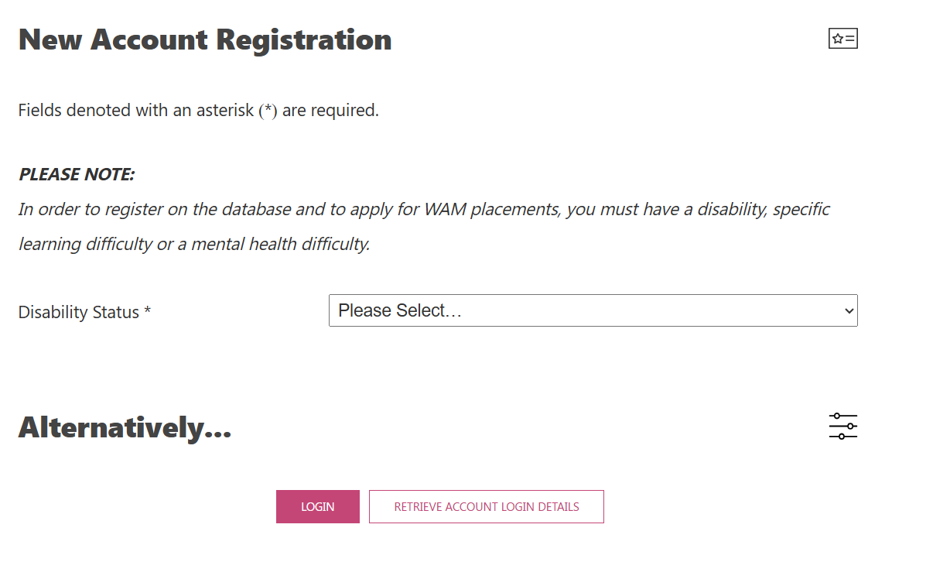

- Select your ‘Disability Status’ and then fill in the required personal information before selecting ‘Create New Account’ at the bottom of the screen.

Please note: In order to register on the database and to apply for WAM placements, you must have a disability, specific learning difficulty or a mental health difficulty.
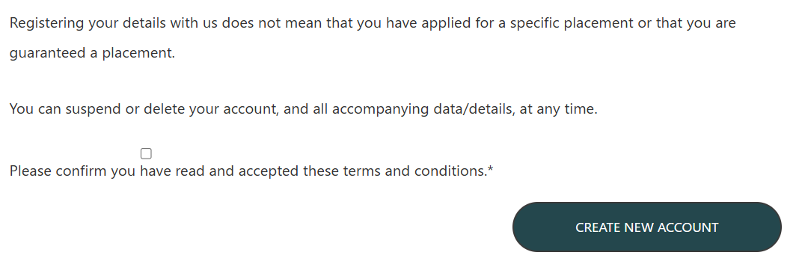

- Once your account has been created, log in to your WAMWorks account using your registered email address and password. Please ensure that your profile information is complete and up to date before proceeding.
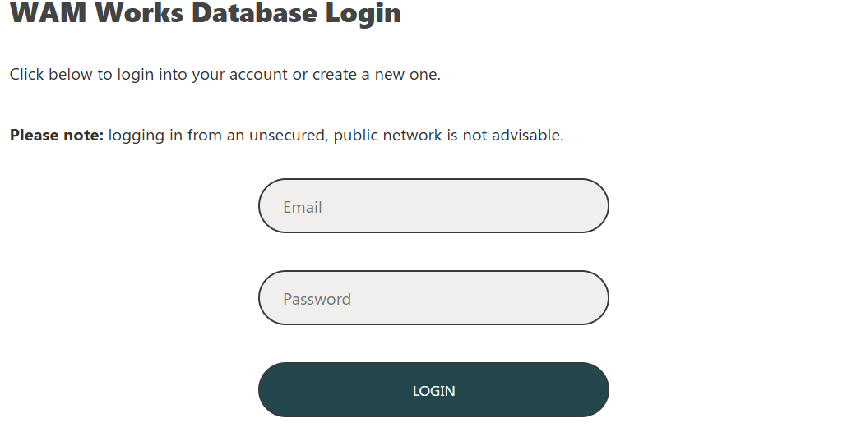

- Select which placement you would like to apply for, in this instance ‘Civil Service: Executive Officer Roles’ from the list available.
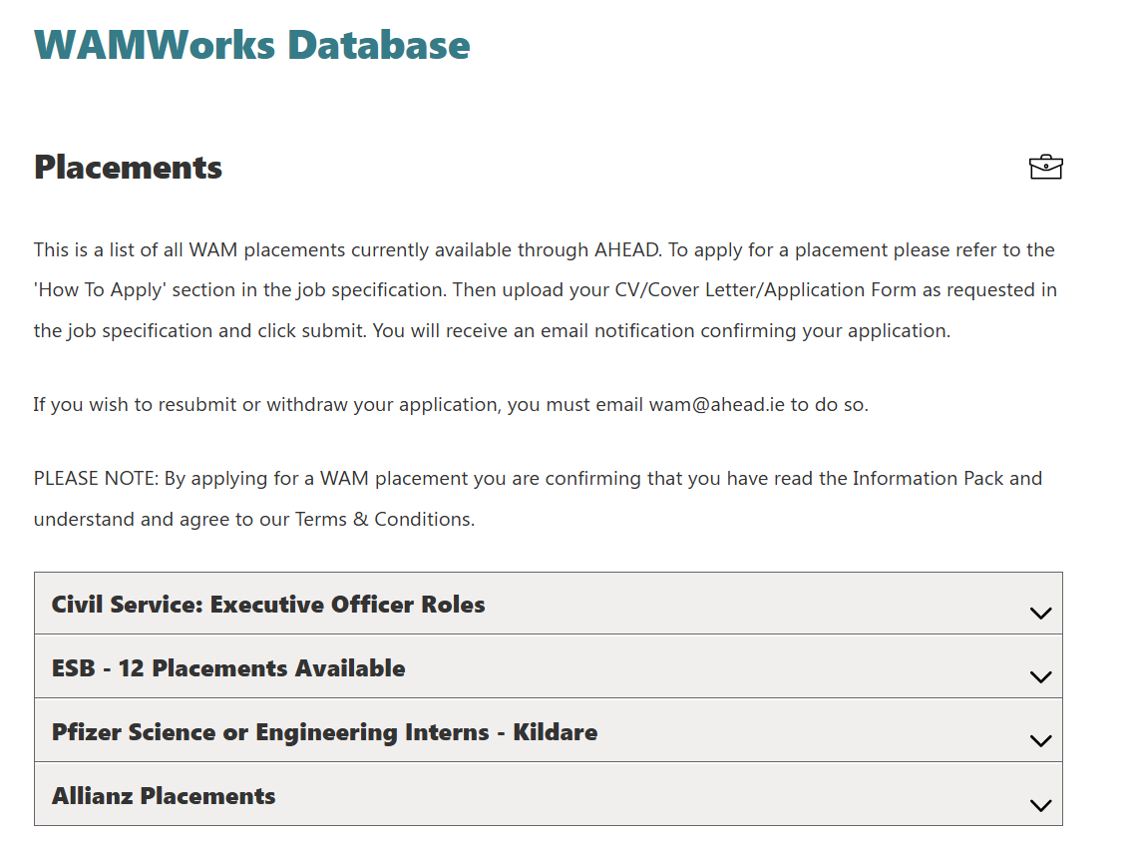

- To upload your completed Civil Service WAM Placement 2027 Application Form click on ‘Choose File’. Select the file you wish to upload, ensure the correct version of the file has been selected and click ‘open’ on the file explorer window.

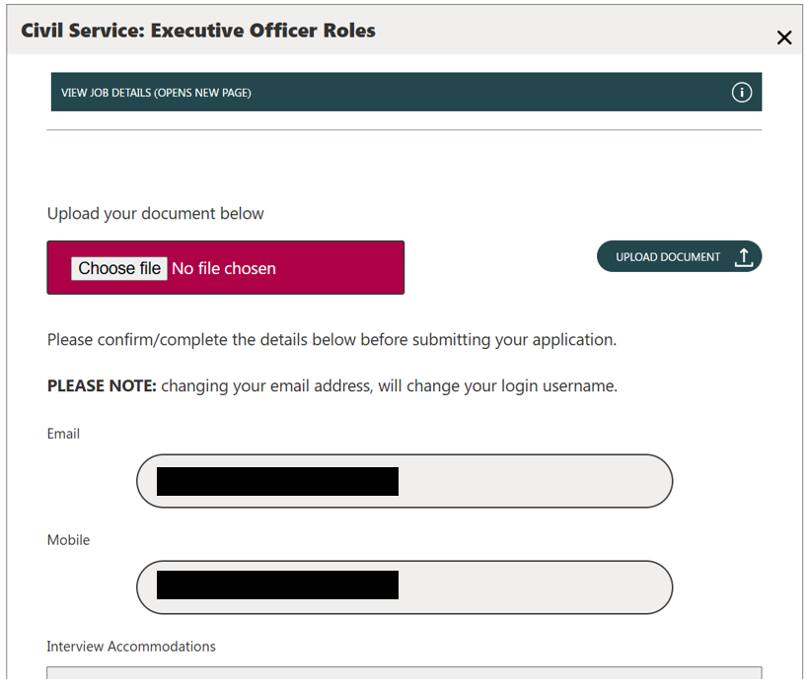
Please note: CVs are not accepted. Incomplete applications or CV submissions will not be considered.

- Please note, selecting your chosen file does not mean that it has been uploaded. To upload your application, select ‘Upload Document’.
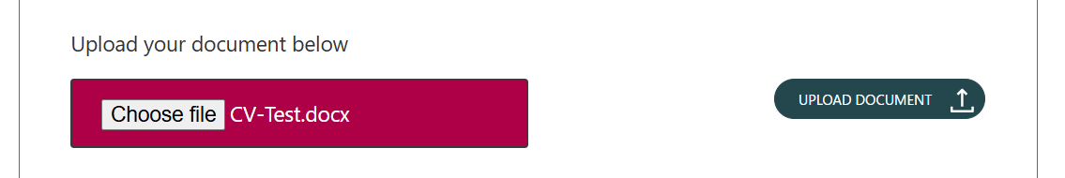

Once your application form has been successfully uploaded, you will receive a pop-up notification as shown below reminding you to fill in the rest of the application information.
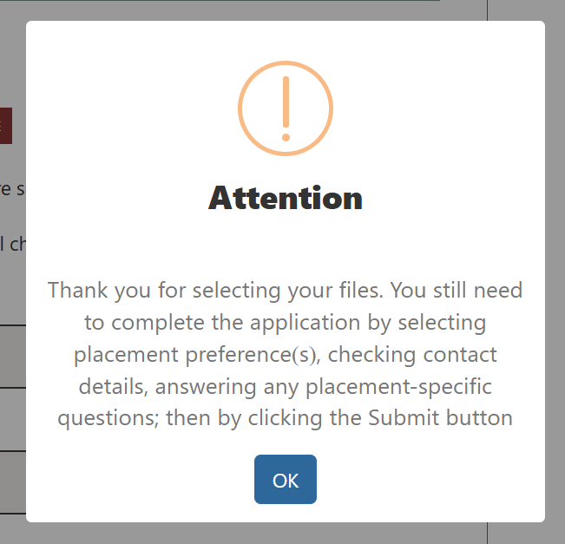

- Complete the application process by selecting your placement preference, checking your contact detail and answering any placement-specific questions. 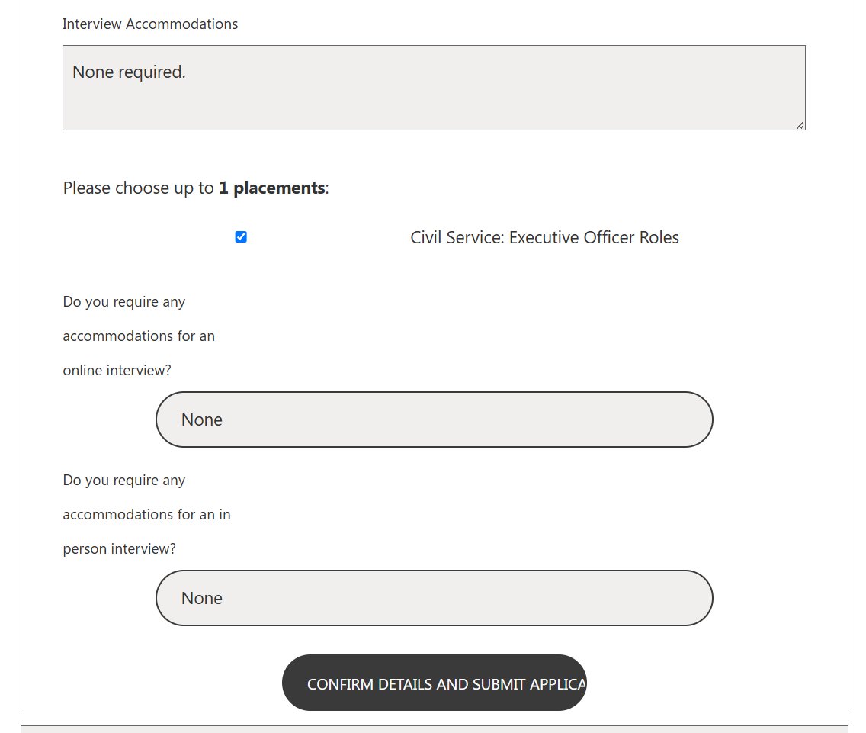

- Once you have confirmed all the details on the application page are correct and you have answered any questions, click ‘CONFIRM DETAILS AND SUBMIT APPLICATION’ at the bottom of the page.

- Another pop-up message will generate confirming you wish you submit your application. If you are certain your contact details are correct and you are ready to apply, click the red ‘Yes, submit application’ button’.
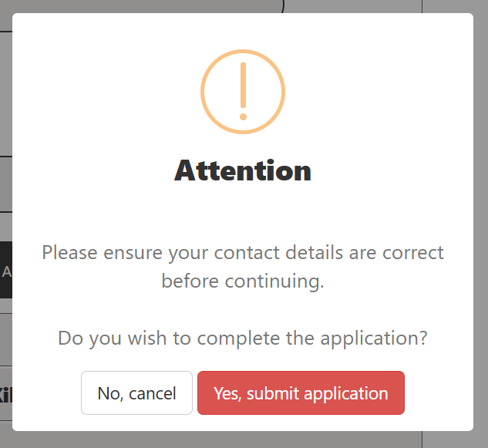
- When your application has successfully been submitted the following message will appear. You will also receive an email confirming receipt of your application.

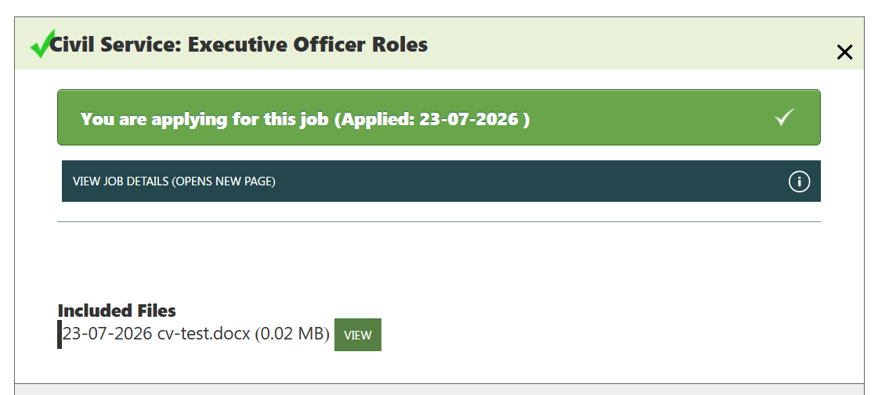

Appendix 3: Registering an Account and Applying via publicjobs.ie
- Please click on this link to Register - publicjobs . Enter your name, email address and password and click I agree and then submit registration.
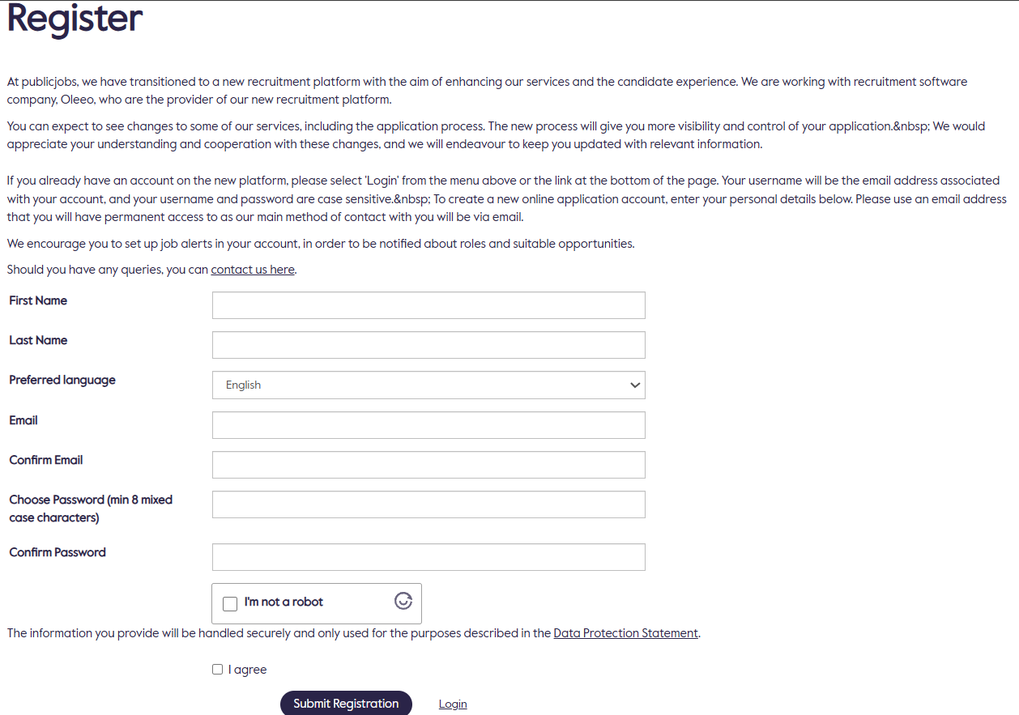

- You will get an email notification to verify your account; you must click on the link that you receive in your email to activate your account.
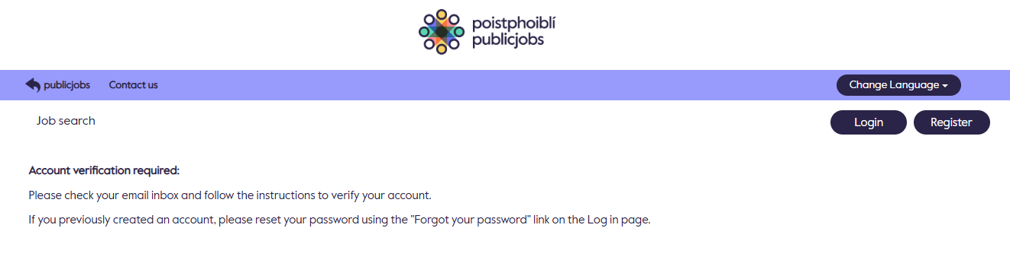
- Once you have activated your account, click on this link provided in this booklet and apply for the campaign.
- Scroll to the bottom of the page and click on the apply now button.
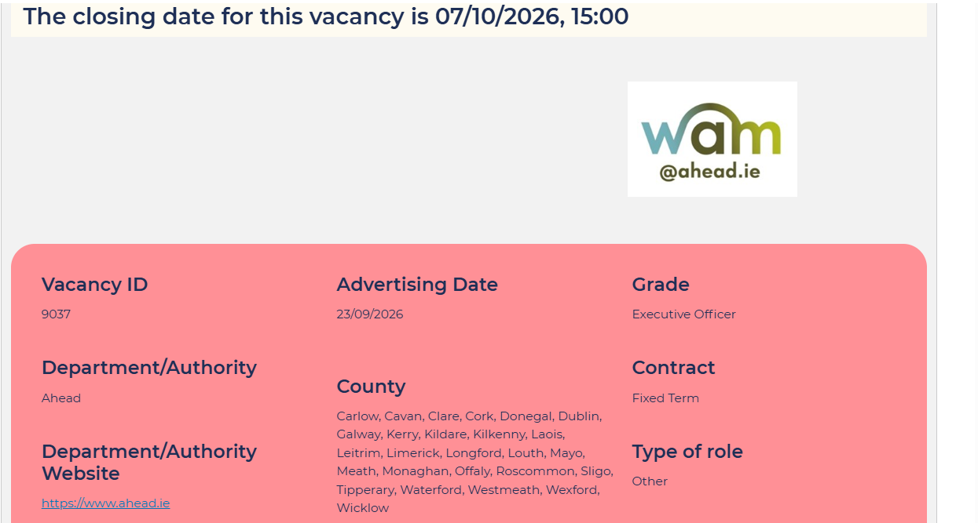
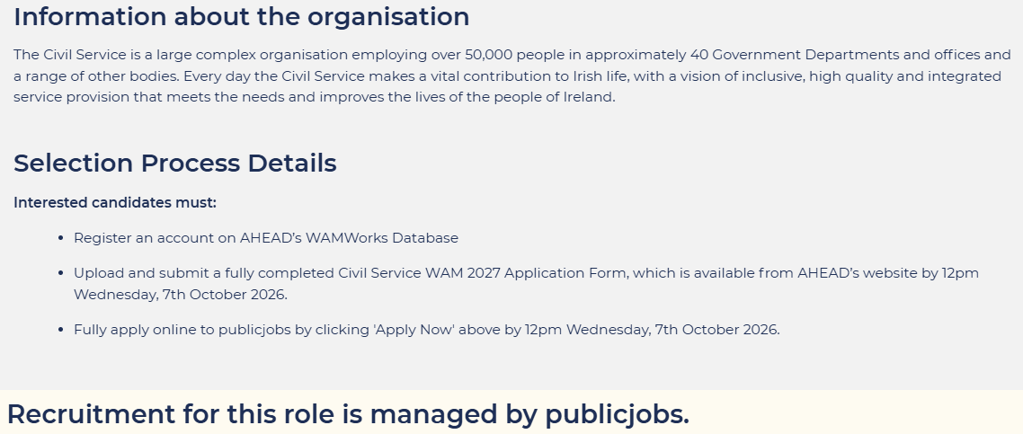

- You will be brought to the application form, on the left hand side of the page you will see a progress checker as you scroll through each of the pages. When you have completed the application form make sure you press submit.
