ESB WAM Graduate Campaign 2027 - How to Apply
This document outlines the two-part process on how to apply for the ESB Graduate Programme. You must complete two separate applications:
- Application through AHEAD’s WAMWorks Database.
- Application through ESB's SuccessFactors through one of the links below.
  - Engineering/Technical Graduate Programme – ESB Success Factors
  - IT Graduate Programme – ESB Success Factors
Your application will only be considered if you successfully submit both applications before the closing date.
Closing date: 12 noon on Wednesday, 21 October 2026

Step 1 – WAMWorks Database
- Visit the WAMWorks Database on AHEAD’s website. If you do not already have a WAMWorks account, select the option to register and create a new account. Complete all required registration details and submit your registration.
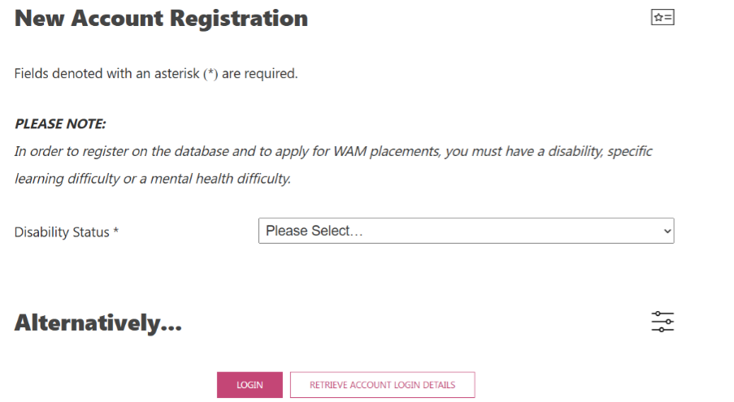
- Select your ‘Disability Status’ and then fill in the required personal information before selecting ‘Create New Account’ at the bottom of the screen.
- Please note: In order to register on the database and to apply for WAM placements, you must have a disability, specific learning difficulty or a mental health difficulty.
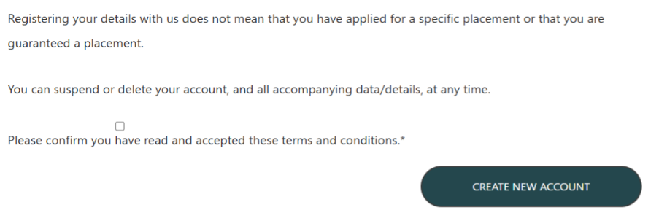
- Once your account has been created, log in to your WAMWorks account using your registered email address and password. Please ensure that your profile information is complete and up to date before proceeding.
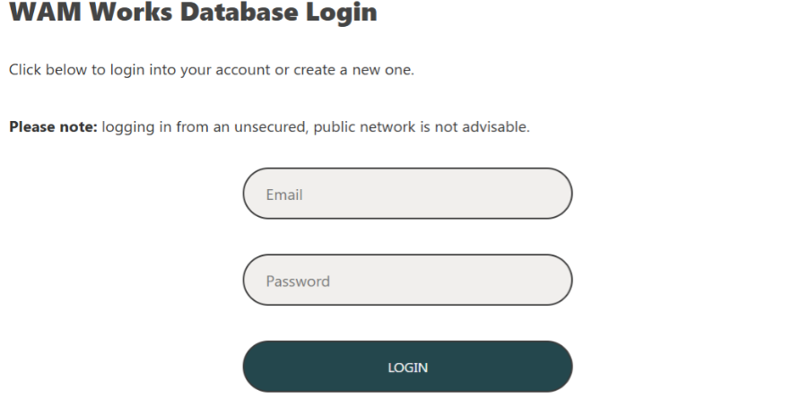
- Select which placement you would like to apply for;
  - the ESB Engineering/Technical Graduate Programme, or;
  - the ESB IT Graduate Programme – Digital Delivery and Project Management.
- Upload your CV by clicking 'Choose file’ and then click ‘Upload Document’
- Please note, selecting your chosen file does not mean that it has been uploaded. To upload your application, select ‘Upload Document’.
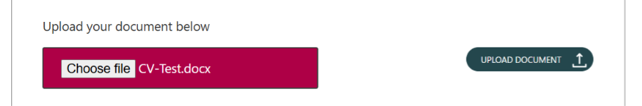
- Once your application form has been successfully uploaded, you will receive a pop-up notification as shown below reminding you to fill in the rest of the application information.
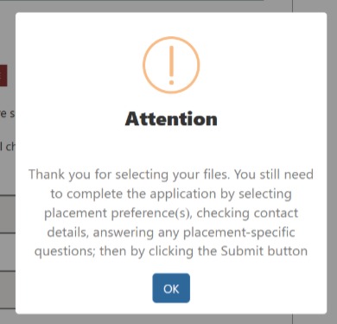
- Complete the application process by selecting your placement preference, checking your contact details and answering any placement-specific questions.
- Once you have confirmed all the details on the application page are correct and you have answered any questions, click ‘CONFIRM DETAILS AND SUBMIT APPLICATION’ at the bottom of the page.
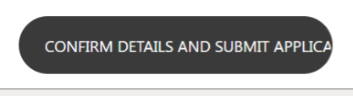
- Another pop-up message will generate confirming you wish you submit your application. If you are certain your contact details are correct and you are ready to apply, click the red ‘Yes, submit application’ button’.
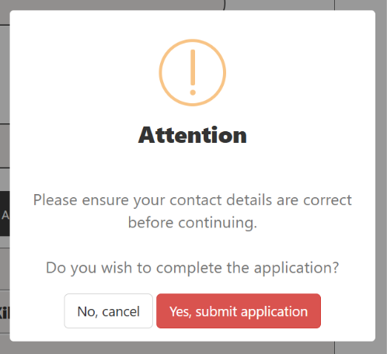
- When your application has successfully been submitted you will receive an email confirming receipt of your application.

Step 2 - ESB Success Factors Application Portal

- Open the relevant link below of which Graduate Programme you are applying for.
  - Engineering/Technical Graduate Programme – ESB Success Factors
  - IT Graduate Programme – ESB Success Factors
- Click the Apply Now button.
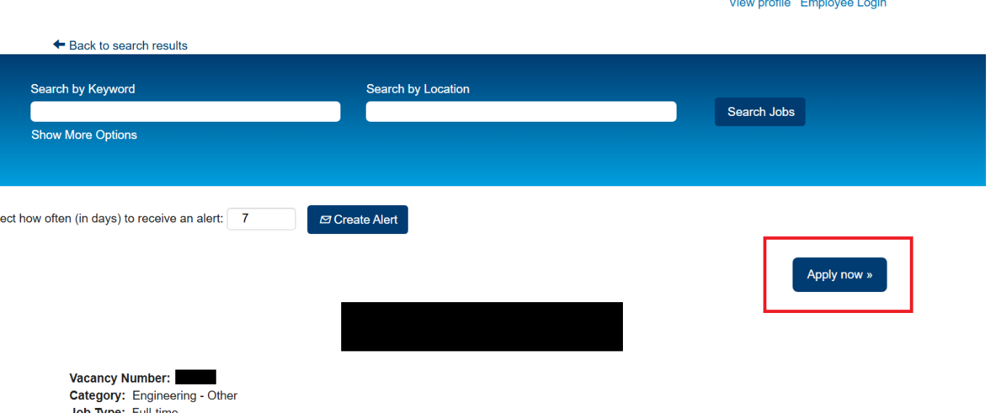
- If you do not have an account with ESB, click the ‘Create an account’ link. If you already have an account, enter your login details.
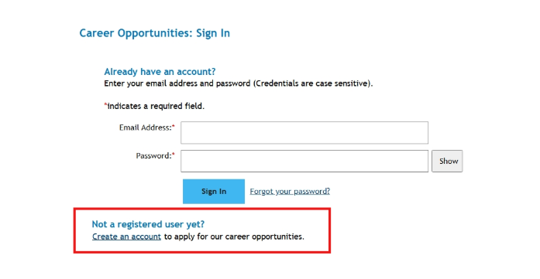
- Complete all mandatory registration details. Note: Please use a personal email address, not a college email, and ensure your name is spelled correctly.
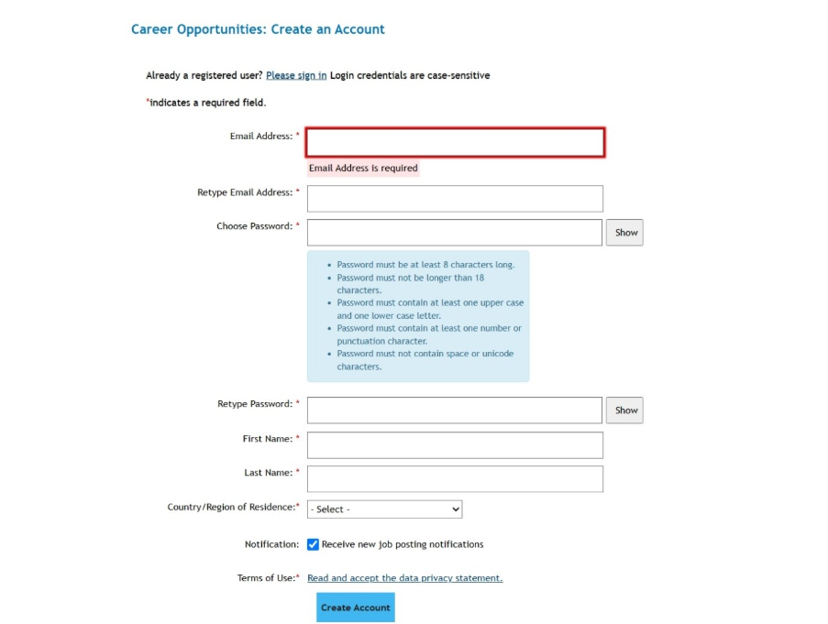
- Once logged in, you will see several drop-down sections. Please complete the following mandatory sections:
  - My Documents
  - Profile Information
  - Job-Specific Information.

The remaining sections are optional and can be completed if you wish.
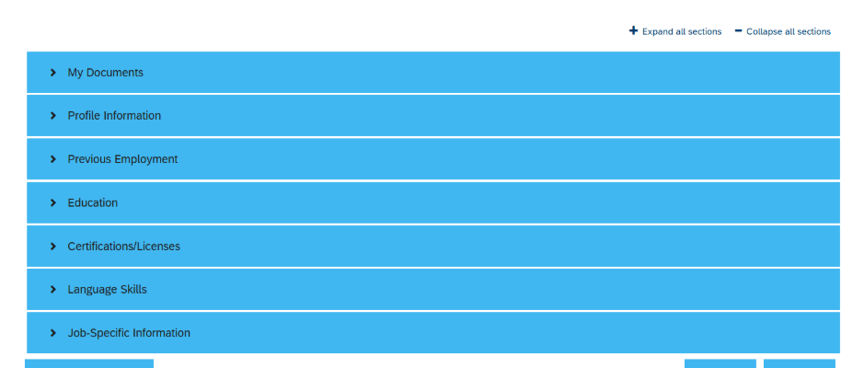
- On the My Documents drop-down men, upload your CV by clicking the click the plus button (+).
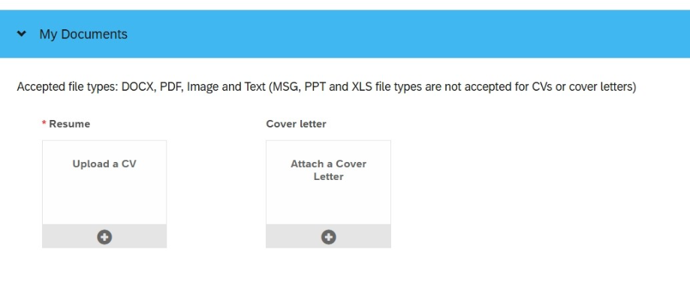
- On the Profile Information drop-down menu, complete the required information.
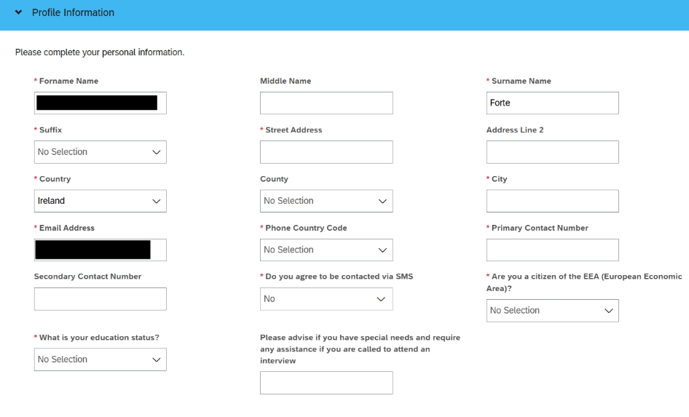
- On the Job-Specific Information drop-down menu and answer all questions.
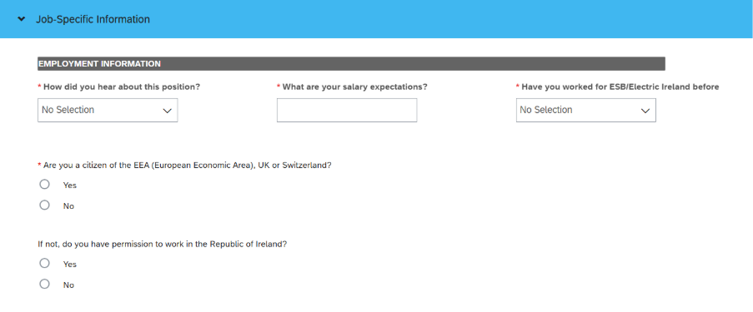
- Once you have completed all required areas of the application, click ‘Apply’ at the end of the application form.
