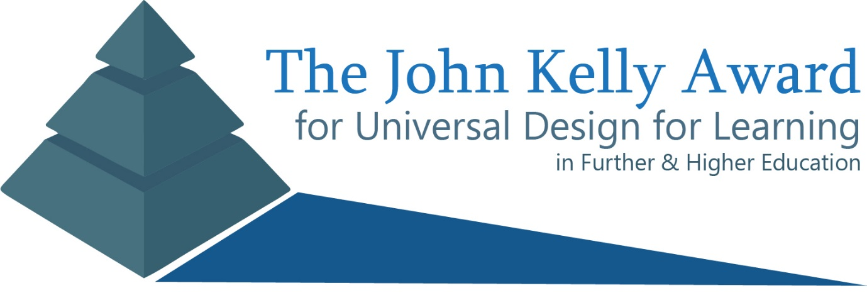

The John Kelly Award – Application Form
The John Kelly Award for Universal Design for Learning recognises the innovative practice of teaching staff in further and higher education engaging with the Universal Design for Learning (UDL) framework to deliver a more inclusive learning experience for their students. It is targeted at practitioners who have demonstrated their emergent commitment to UDL by undertaking the Digital Badge for Universal Design in Teaching & Learning and making exciting changes to their practice as a result of their participation in the badge. Shortlisted applicants will be granted free access to AHEAD’s annual conference on inclusive education and a platform to showcase their work and the eventual winner will receive €1,000 to go towards their continuing professional development in this area.

Application Criteria
The application criteria is simple – if you have completed the Digital Badge for Universal Design in Teaching & Learning in the 2 year period before Jan 20th 2020 and you feel that the changes you demonstrated in the assignment you delivered as part of the badge made a significant positive impact your student’s learning, then you are eligible to apply. Please note that shortlisted candidates must be available to showcase their digital badge work via a very short presentation at the AHEAD conference 2020 (March 27th 2020, Croke Park Dublin) since the judging panel will make their final decision based on these presentations. If shortlisted candidates are unable to meet this commitment then they will be removed from the shortlist but will be eligible to apply again in future years.
Please complete this form and return it to dara.ryder@ahead.ie with your digital badge assignment attached (or linked to below) by Mon Jan 27th 2020.

Please note that the personal data collected in this form will only be used by AHEAD to administer the John Kelly Award and will not be shared with any third parties. If you answer ‘Yes’ in the ‘let us share your work’ field’, we may use a summary of your work to promote engagement with the digital badge programme and the UDL framework and/or as a sample for future students as the kinds of changes they can make. All shortlisted finalists will have their final presentations recorded and shared with the sector as exemplars of good UDL practice.

Contact Details:
Name:
Position:
Institution:
Email Address:
Telephone Number:

About Your Digital Badge:
In this section we need to verify that you have completed the digital badge. When you graduated from the digital badge programme, you would have received an email from the National Forum for the Enhancement of Teaching and Learning with a link to view and collect your digital badge.
If you have the link to your digital badge available, please enter it in the box below:

If you do not have link available, please enter the email address that you used while undertaking the course in the box below and we will verify that a badge was issued to this address:

For this application to be considered complete, you must either attach the assignment report you completed as part of the digital badge for Universal Design in Teaching and Learning course to the same email as this application, or provide a link below.
Please provide a link to your Digital Badge assignment report below or enter the word ‘ATTACHED’ in the box below if you intend to attach it to the same email as this application:

Summarise Your Digital Badge Work:
What was the title of the module/teaching activity which you reflected on/changed as part of your digital badge assignment?

In the box below, please give a 200-300 summary on the key change/changes you made to your teaching and learning practice as a result of your digital badge assignment – this summary should reflect what is contained in the assignment report you have linked to/attached above:
Lastly, please give a 50 – 100 word reflection on how your engagement with the UDL/UDI framework (via the digital badge programme) has changed the way you think about/practice teaching and learning more generally:

Let Us Share Your Work
We would like to have the opportunity to share the summaries and reflections you’ve written in the section above along with your position and the module title you worked on (no individual name or institution will be published) as part of our promotion of the digital badge and the UDL framework and to future digital badge students seeking inspiration about what they could change in their practice. Would you like to grant us permission to share this information?
YES/NO

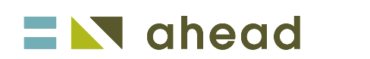
Please complete this form and return it to christine.hynes@ahead.ie with your digital badge assignment attached (or linked to below) by Jan 27th 2020.

